SUBCOURSE EDITION
QM0454 0

FOOD PREPARATION PART I

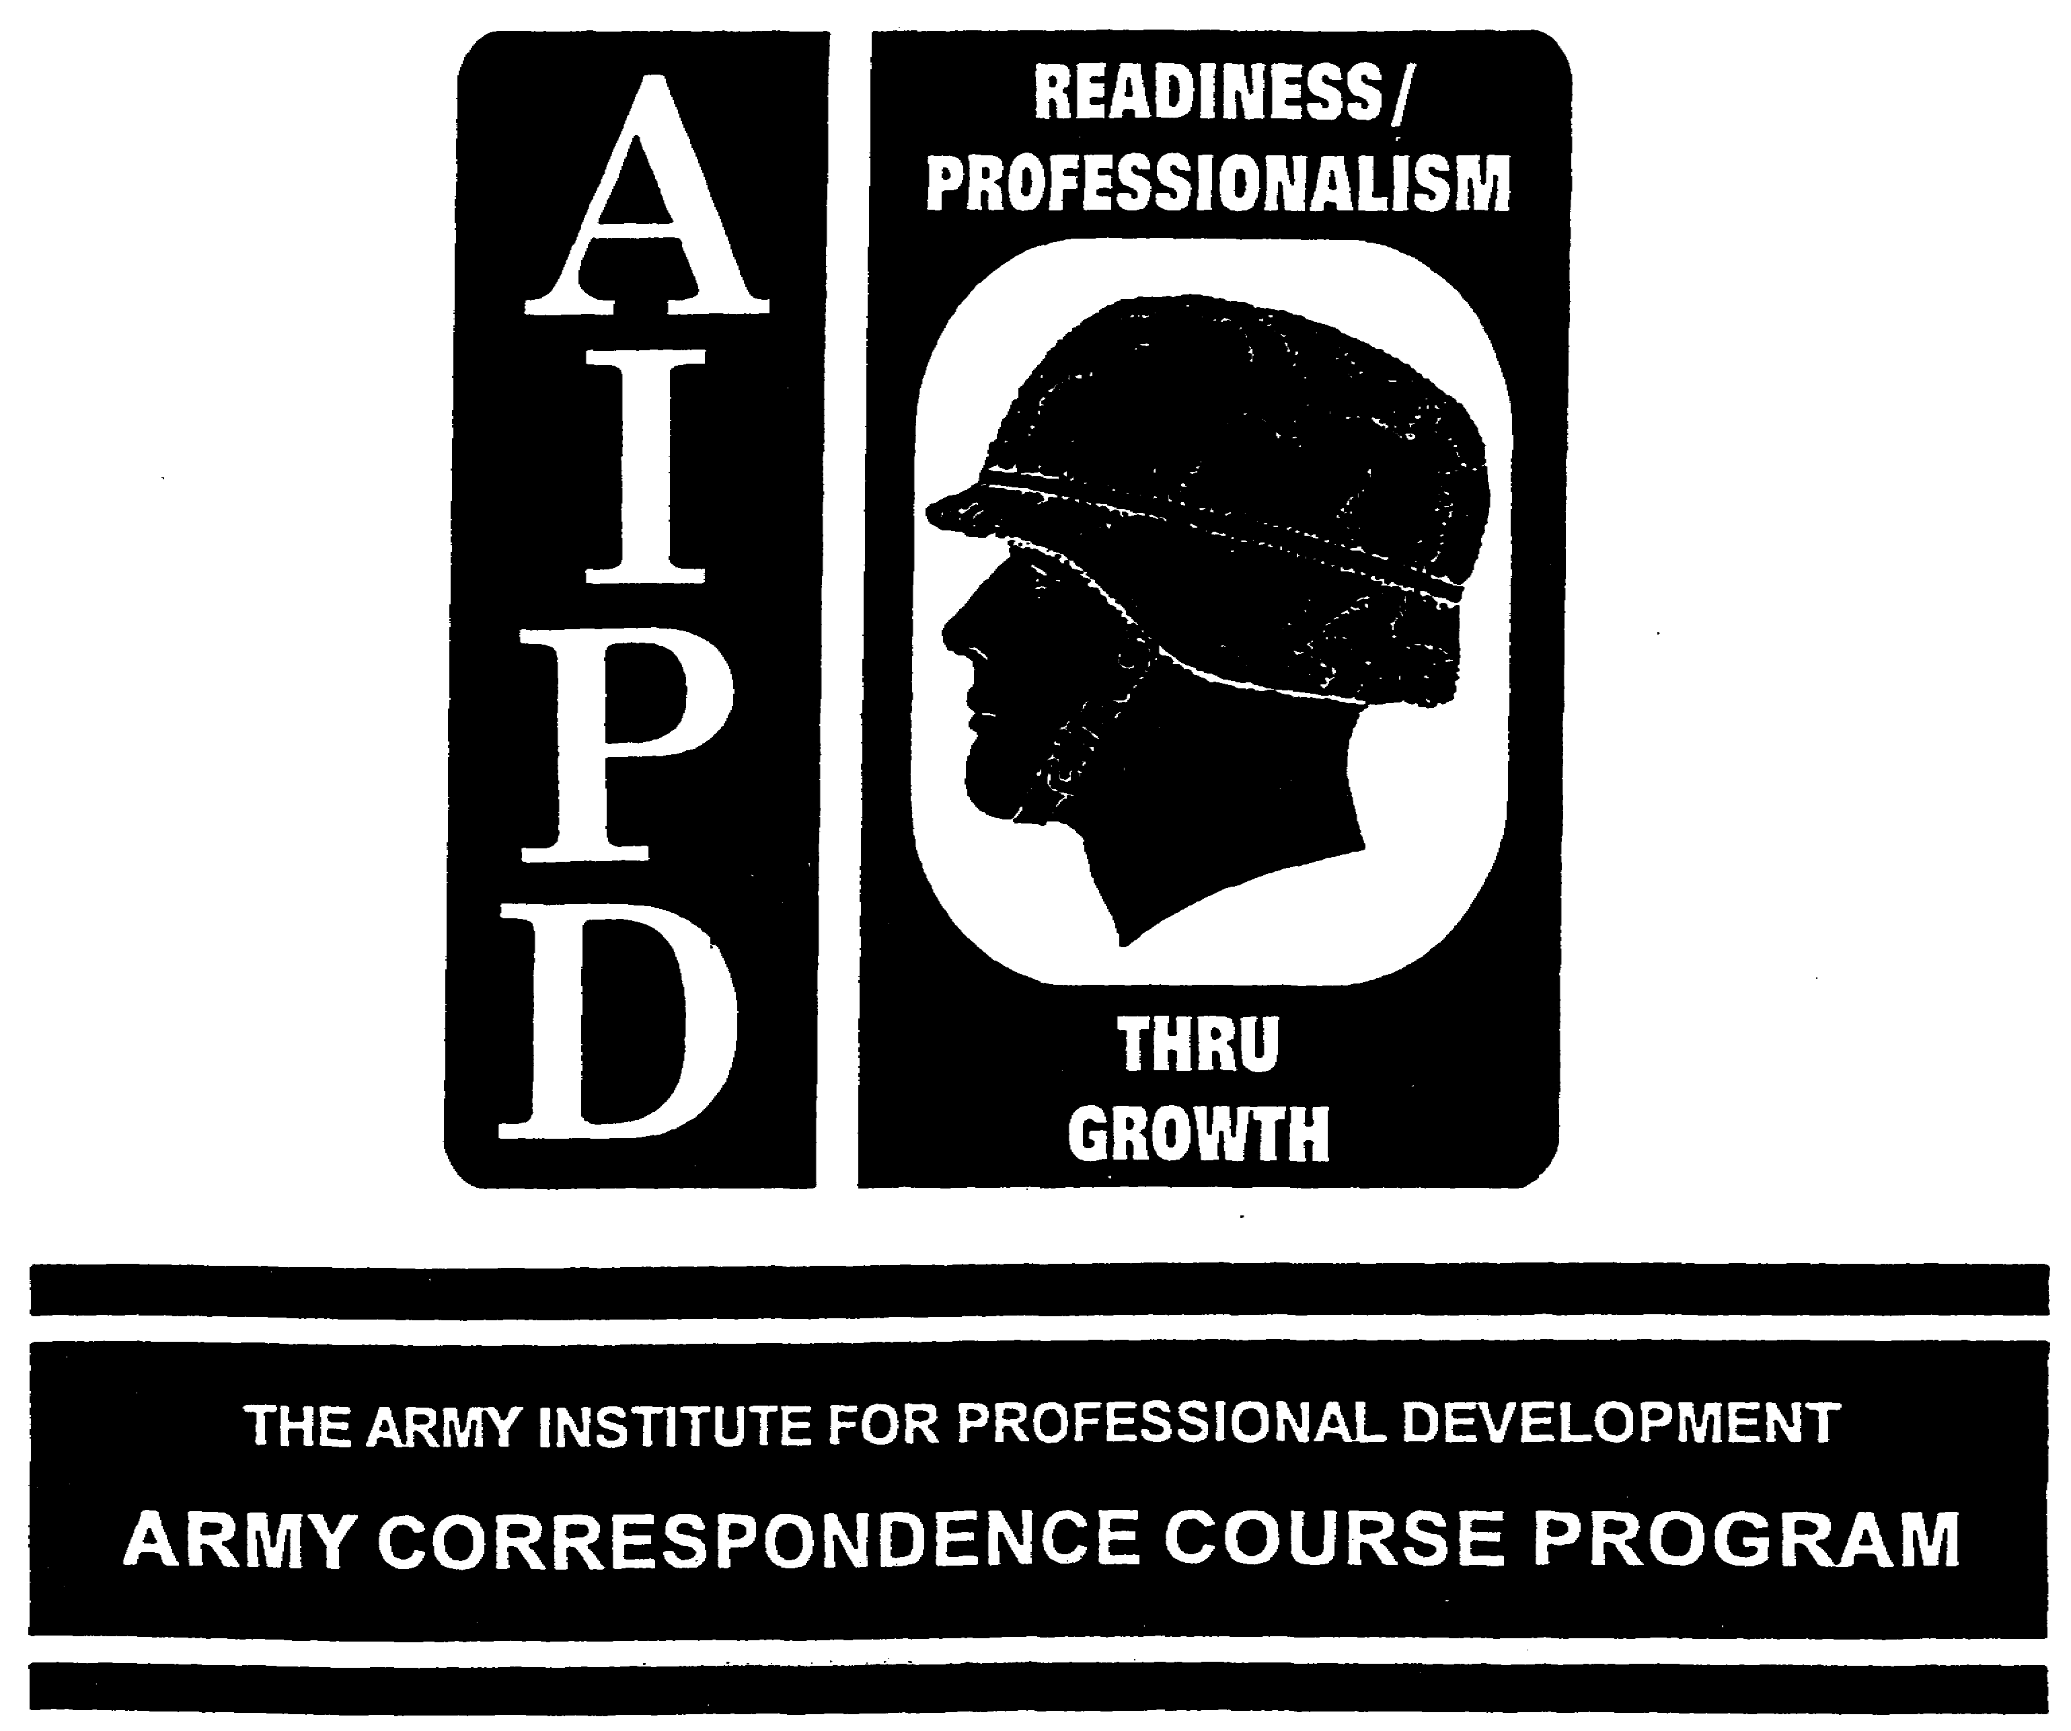

QM0454
FOOD PREPARATION, PART I
Edition 0

7 Credit Hours

United States Army Combined Arms Support Command
Fort Lee, VA 23801-1809

CONTENTS
Page

Introduction iii

Lesson 1 - Task No. 101-524-1151. Perform Preliminary Food 1
Preparation Procedures

Review Exercises 12

Exercise Solutions 14

Lesson 2 - Task No. 101-524-1152. Prepare and Cook Meat, 15
Poultry, and Seafood

Review Exercise A 23

Exercise Solution A 25

Review Exercise B 30

Exercise Solution B 32

Review Exercise C 36

Exercise Solution C 38

Lesson 3 - Task No. 101-524-1158. Prepare and Cook Desserts 39
Other than Pastries

Review Exercises 51

Exercise Solutions 53

Lesson 4 - Task No. 101-524-1162. Prepare and Cook Egg 55
Products

Review Exercises 61

Exercise Solutions 63

i
Lesson 5 - Task No. 101-524-1163. Prepare and Cook Cereal 65
or Paste Products

Review Exercises 72

Exercise Solutions 74

Lesson 6 - Task No. 101-524-1164. Prepare Beverages 75

Review Exercises 79

Exercise Solutions 80

ii

INTRODUCTION

This subcourse contains multiple lessons/tasks on food preparation procedures. We will cover each part of each task and what your responsibilities are when preparing food.

Supplementary Training Material Provided: None.

Material to be Provided by the Student: None.

Material to be Provided by the Unit Supervisor: None.

This subcourse cannot be completed without the above material.

Seven credit hours will be awarded for successful completion of this subcourse.

*** IMPORTANT NOTICE ***

THE PASSING SCORE FOR ALL ACCP MATERIAL IS NOW 70%.

PLEASE DISREGARD ALL REFERENCES TO THE 75% REQUIREMENT.

iii

LESSON 1

OBJECTIVE Task No 101-524-1151. Perform Preliminary Food Preparation Procedures.

TASK: When you successfully complete this assignment, you will be able to perform preliminary food preparation procedures. This includes the following performance measures:

1. Read and interpret the Production Schedule.

a. Check to see what product is to be prepared.

b. Check to see how many portions are to be prepared.

c. Check to see which recipe card, SOP, or master menu note is to be used.

d. Check the time to start preparation.

e. Check the time to start cooking the item.

f. Check for special instructions.

2. Read aid interpret the recipe card, SOP, or master menu note.

a. Check to see what ingredients are needed.

b. Determine what equipment, hand tools, and utensils are needed.

3. Prepare equipment for use.

a. Assemble and attach all accessories.

b. Plug in electrical equipment in a garrison facility.

c. Light gas or oil-fired equipment.

d. Preheat equipment, when necessary.

1

4. Assemble utensils and handtools.

a. Obtain cutlery tools.

b. Obtain measuring devices.

c. Obtain required cooking baking utensils.

d. Sanitize equipment and utensils for use with potentially hazardous food before use.

5. Wash hands before handling any food product.

6. Assemble the ingredients.

a. Obtain all nonperishable ingredients.

b. Obtain required seasonings.

c. Obtain all perishable ingredients.

CONDITIONS: You are a cook assigned to a garrison dining facility or a field kitchen. You must perform preliminary food preparation procedure for any menu item and any number of servings. For evaluation, you will be given a situation requiring you to complete selected performance measures for not more than 10 items. This task is performed in a garrison dining facility or in a simulated combat situation under all environmental conditions.

CREDIT HOURS: 1

REFERENCES: AR 30-1, The Army Food Service Program
AR 40-5, Health and Environment
TM 10-412, Armed Forces Recipe Cards
TM 10-415, Dining Facility Equipment: Operation
and Operator Maintenance
FM 10-25, Preparation and Serving of Food in the
Garrison Dining Facility

2

LESSON TEXT

1. INTRODUCTION. The objectives of good food preparation are to conserve the nutritive value of the food; to improve the digestibility, to develop and enhance flavor and attractiveness of original color, shape or form, and texture; and to free the food from injurious organisms and substances.

2. READ AND INTERPRET THE PRODUCTION SCHEDULE. The DA Form 3034 (fig. 1) is used by the food service sergeant to provide instructions to cook personnel on the preparation and service of meals, use of leftovers, and to document the disposition of all subsistence items received in the dining facility. The production schedule is the food service sergeant's written instructions, therefore, it must be accurately prepared and followed. The form includes a list of the different food items to be prepared, recipes to be used, individual cook designated to prepare each item, quantity or portion to be prepared, the time that preparation and cooking is to begin, quantity and disposition of leftovers and such other instructions as deemed necessary by the food service sergeant. Space is also provided for the food service sergeant or cook to enter comments pertaining to quality or acceptability of menu items, and items to be discussed during scheduled dining facility staff meetings.

a. A production schedule will be prepared for each meal (breakfast, lunch, dinner, short order, specialty, box lunches, etc.). More than one production schedule may be prepared for use in each separate production area, such as pastry, salads, box lunches.

b. The production schedule stencil may be used for meals when standard menu components are used, such as a la carte breakfast, short order, specialty menus, etc. DA Form 3034 preparation instructions are indicated in figure la. When an item appearing on the form is not served for a particular meal, the -food service sergeant will line through and initial the item in column a.

c. The DA Form 3034 will be completed by legibly writing, printing or typing all entries. The only exception to using blue or black ink will be the use of red ink to record leftovers and their utilization. Leftovers authorized for use in subsequent meals, columns a through j will be posted in red. The reason for all discarded subsistence (column i) will be explained in column 1 and discussed at the next cook's meeting. The production schedule must be completed with care, using standard recipes (TM 10-412), common sense and in a way that can be easily followed by the cooks. Changes posted to the production worksheet must be initialed by the individual making the change. Detailed requirements are depicted in figure 1 and 1a.

3

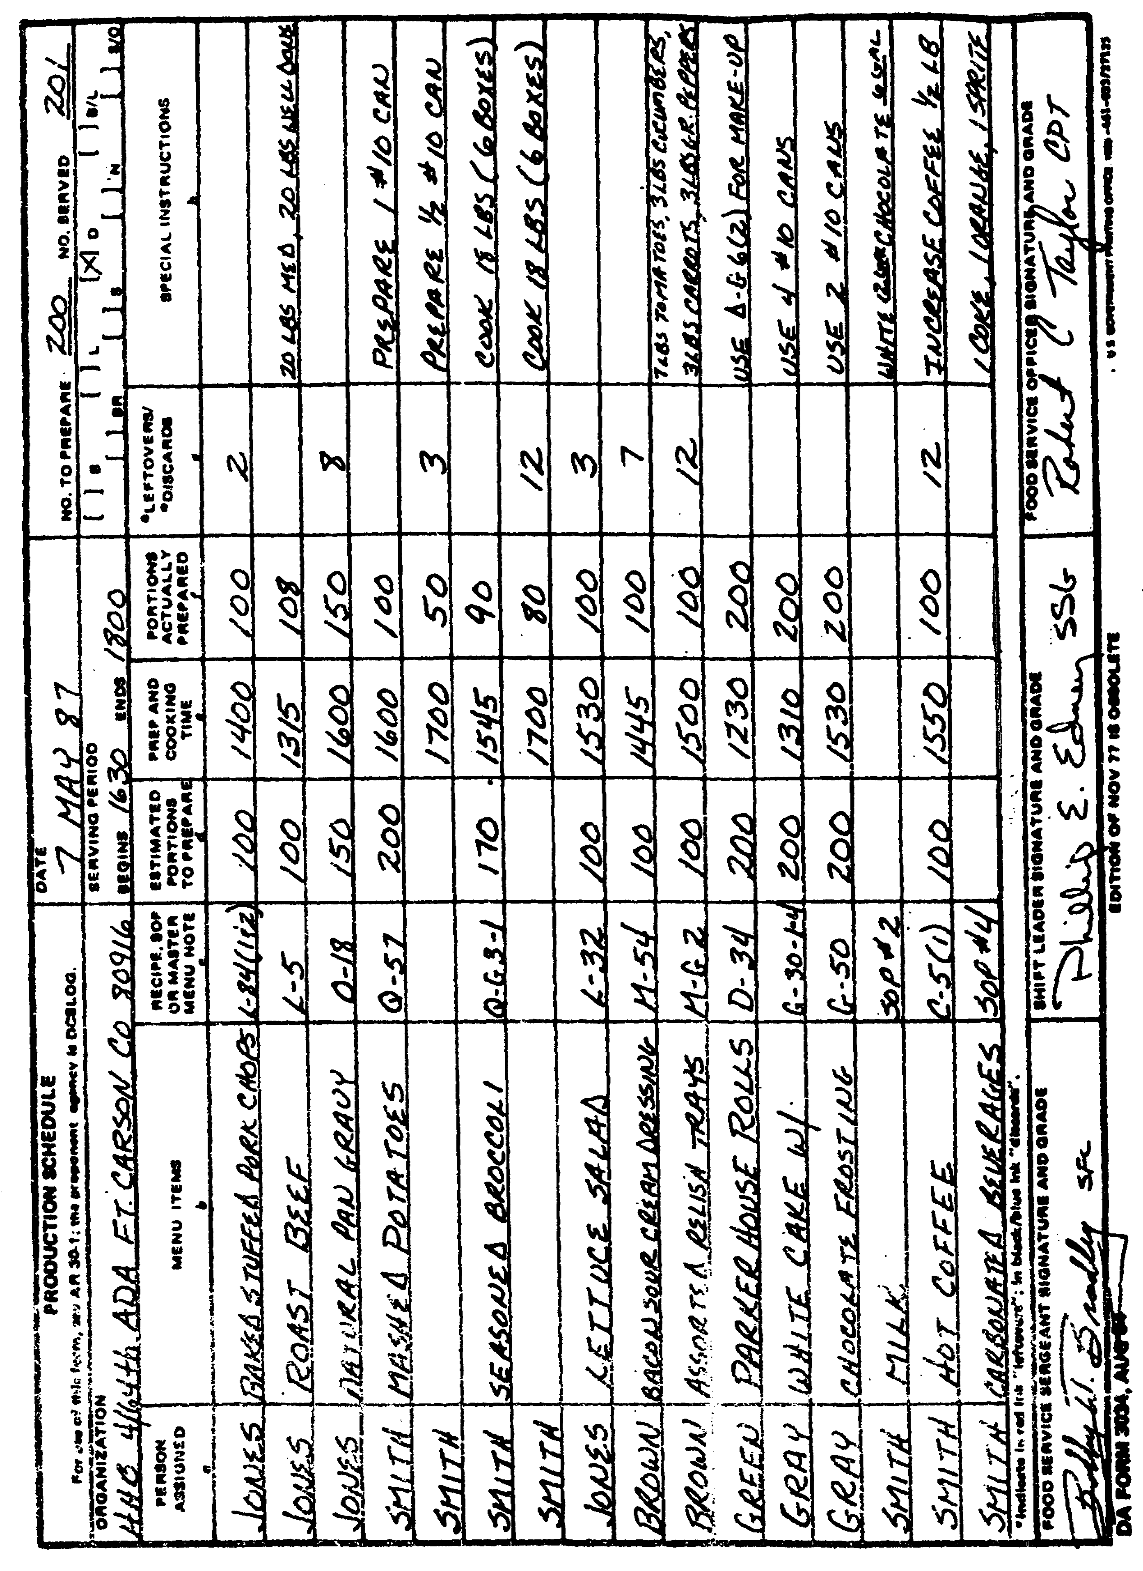

Figure 1. Production Schedule (DA Form 3034)

4

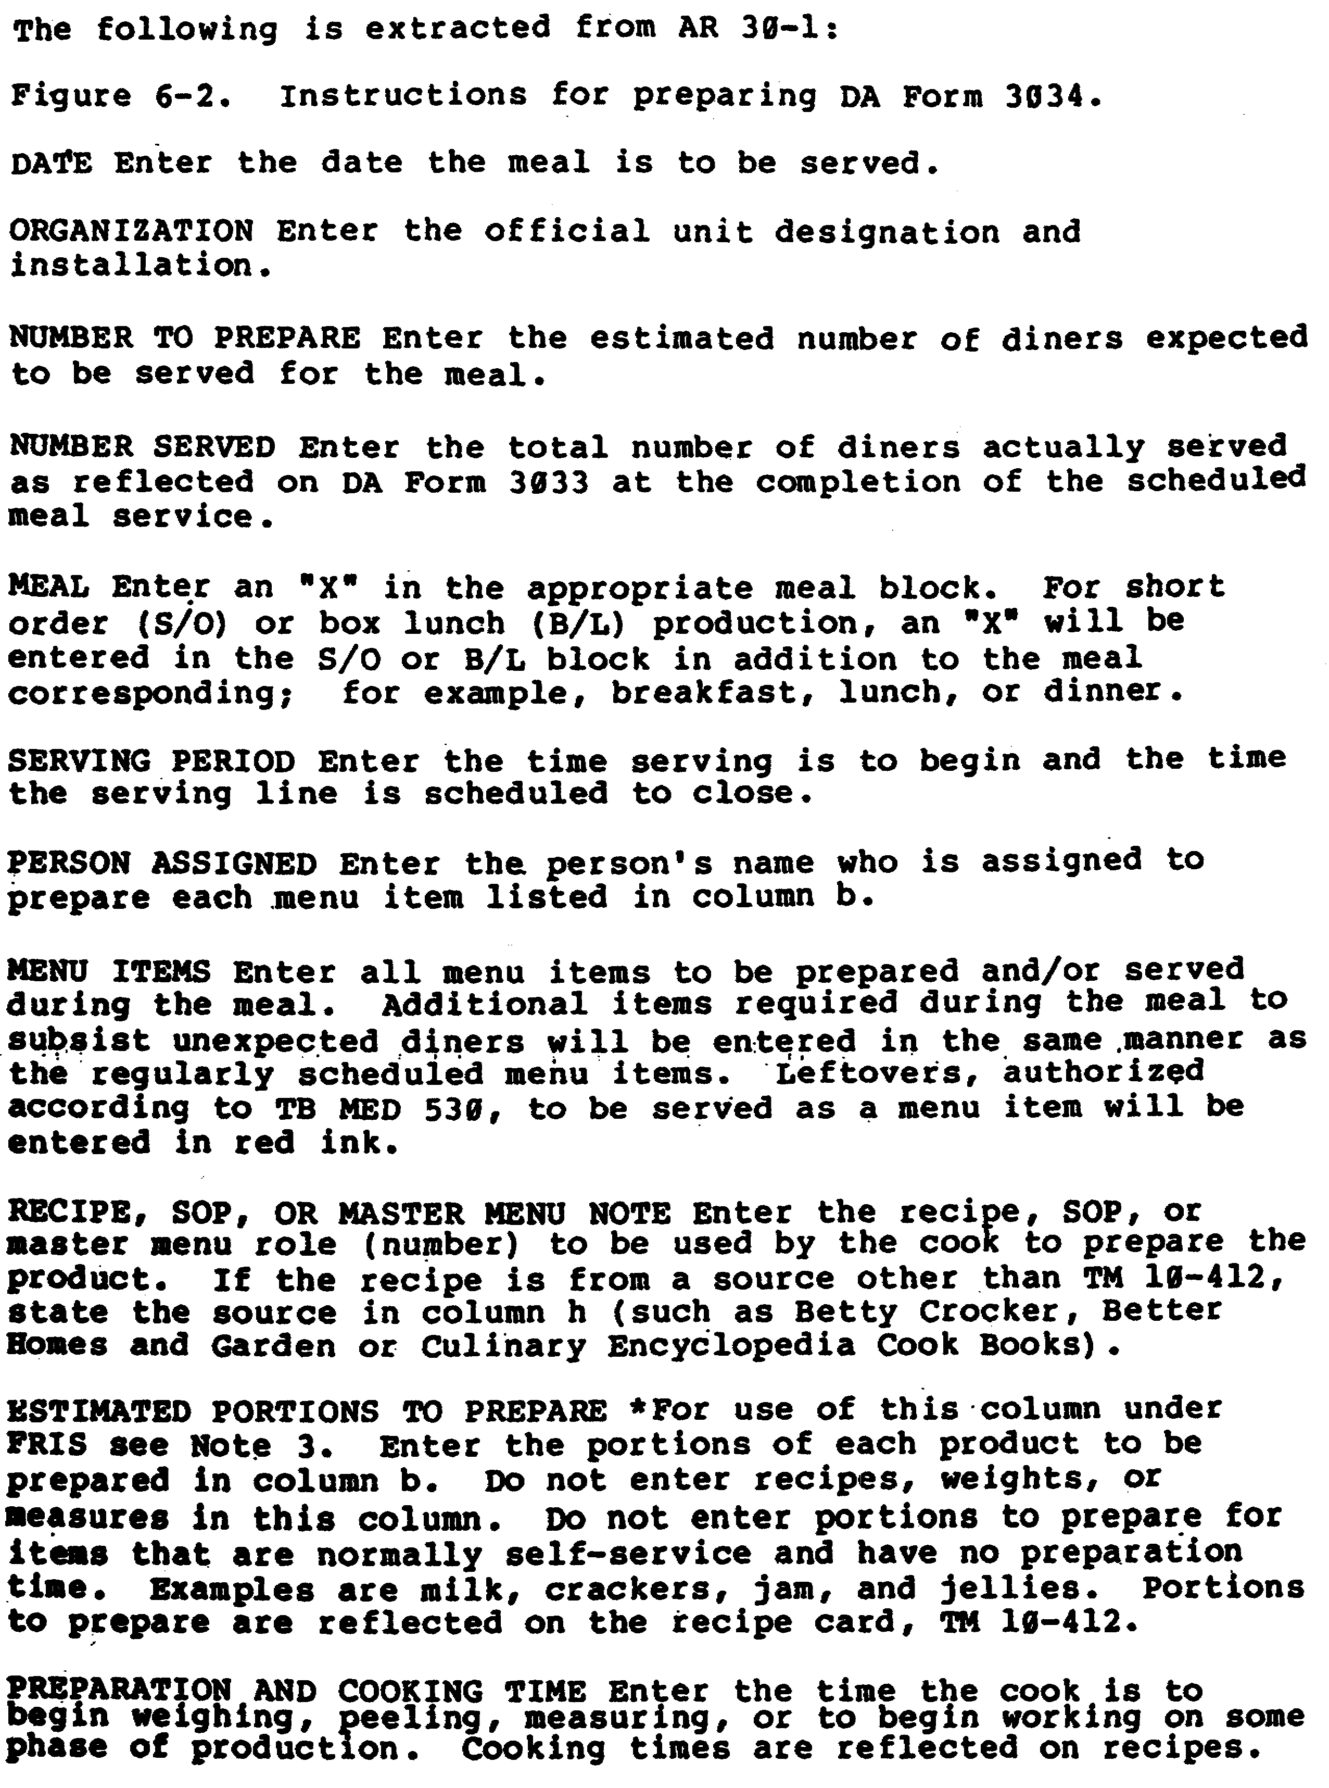

Figure 1a. Instructions for Completing DA Form 3034

4a

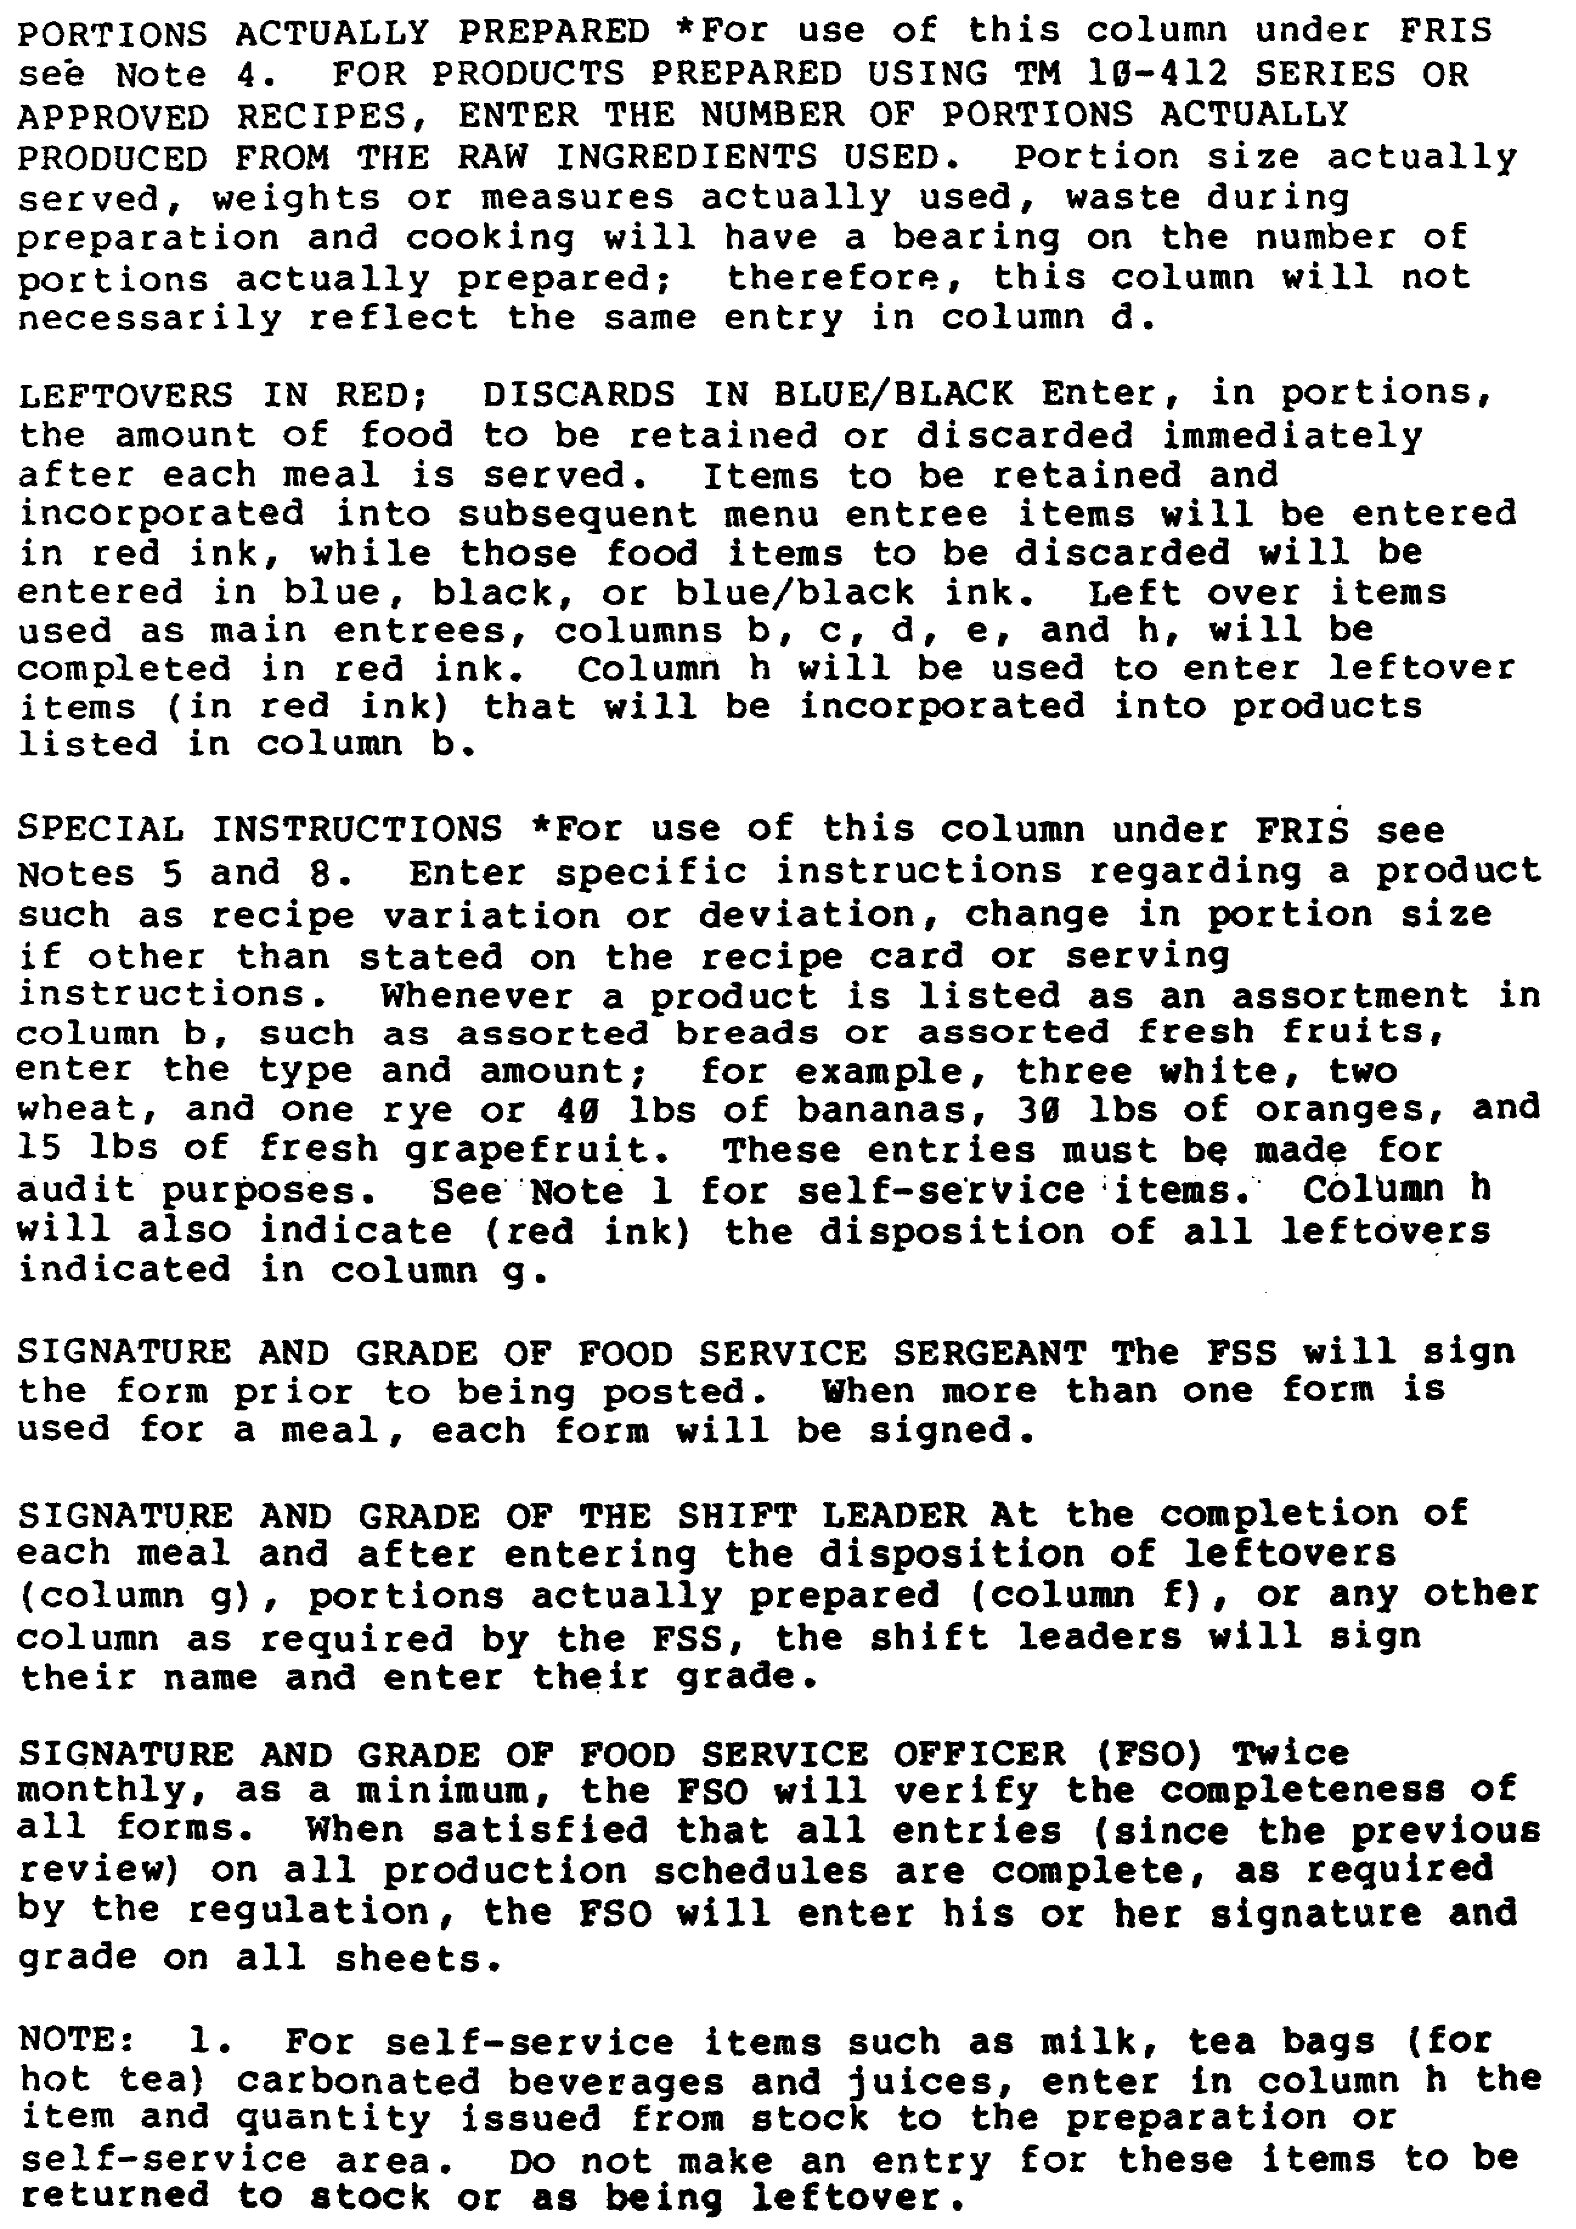

Figure 1a. Instructions for Completing DA Form 3034

4b

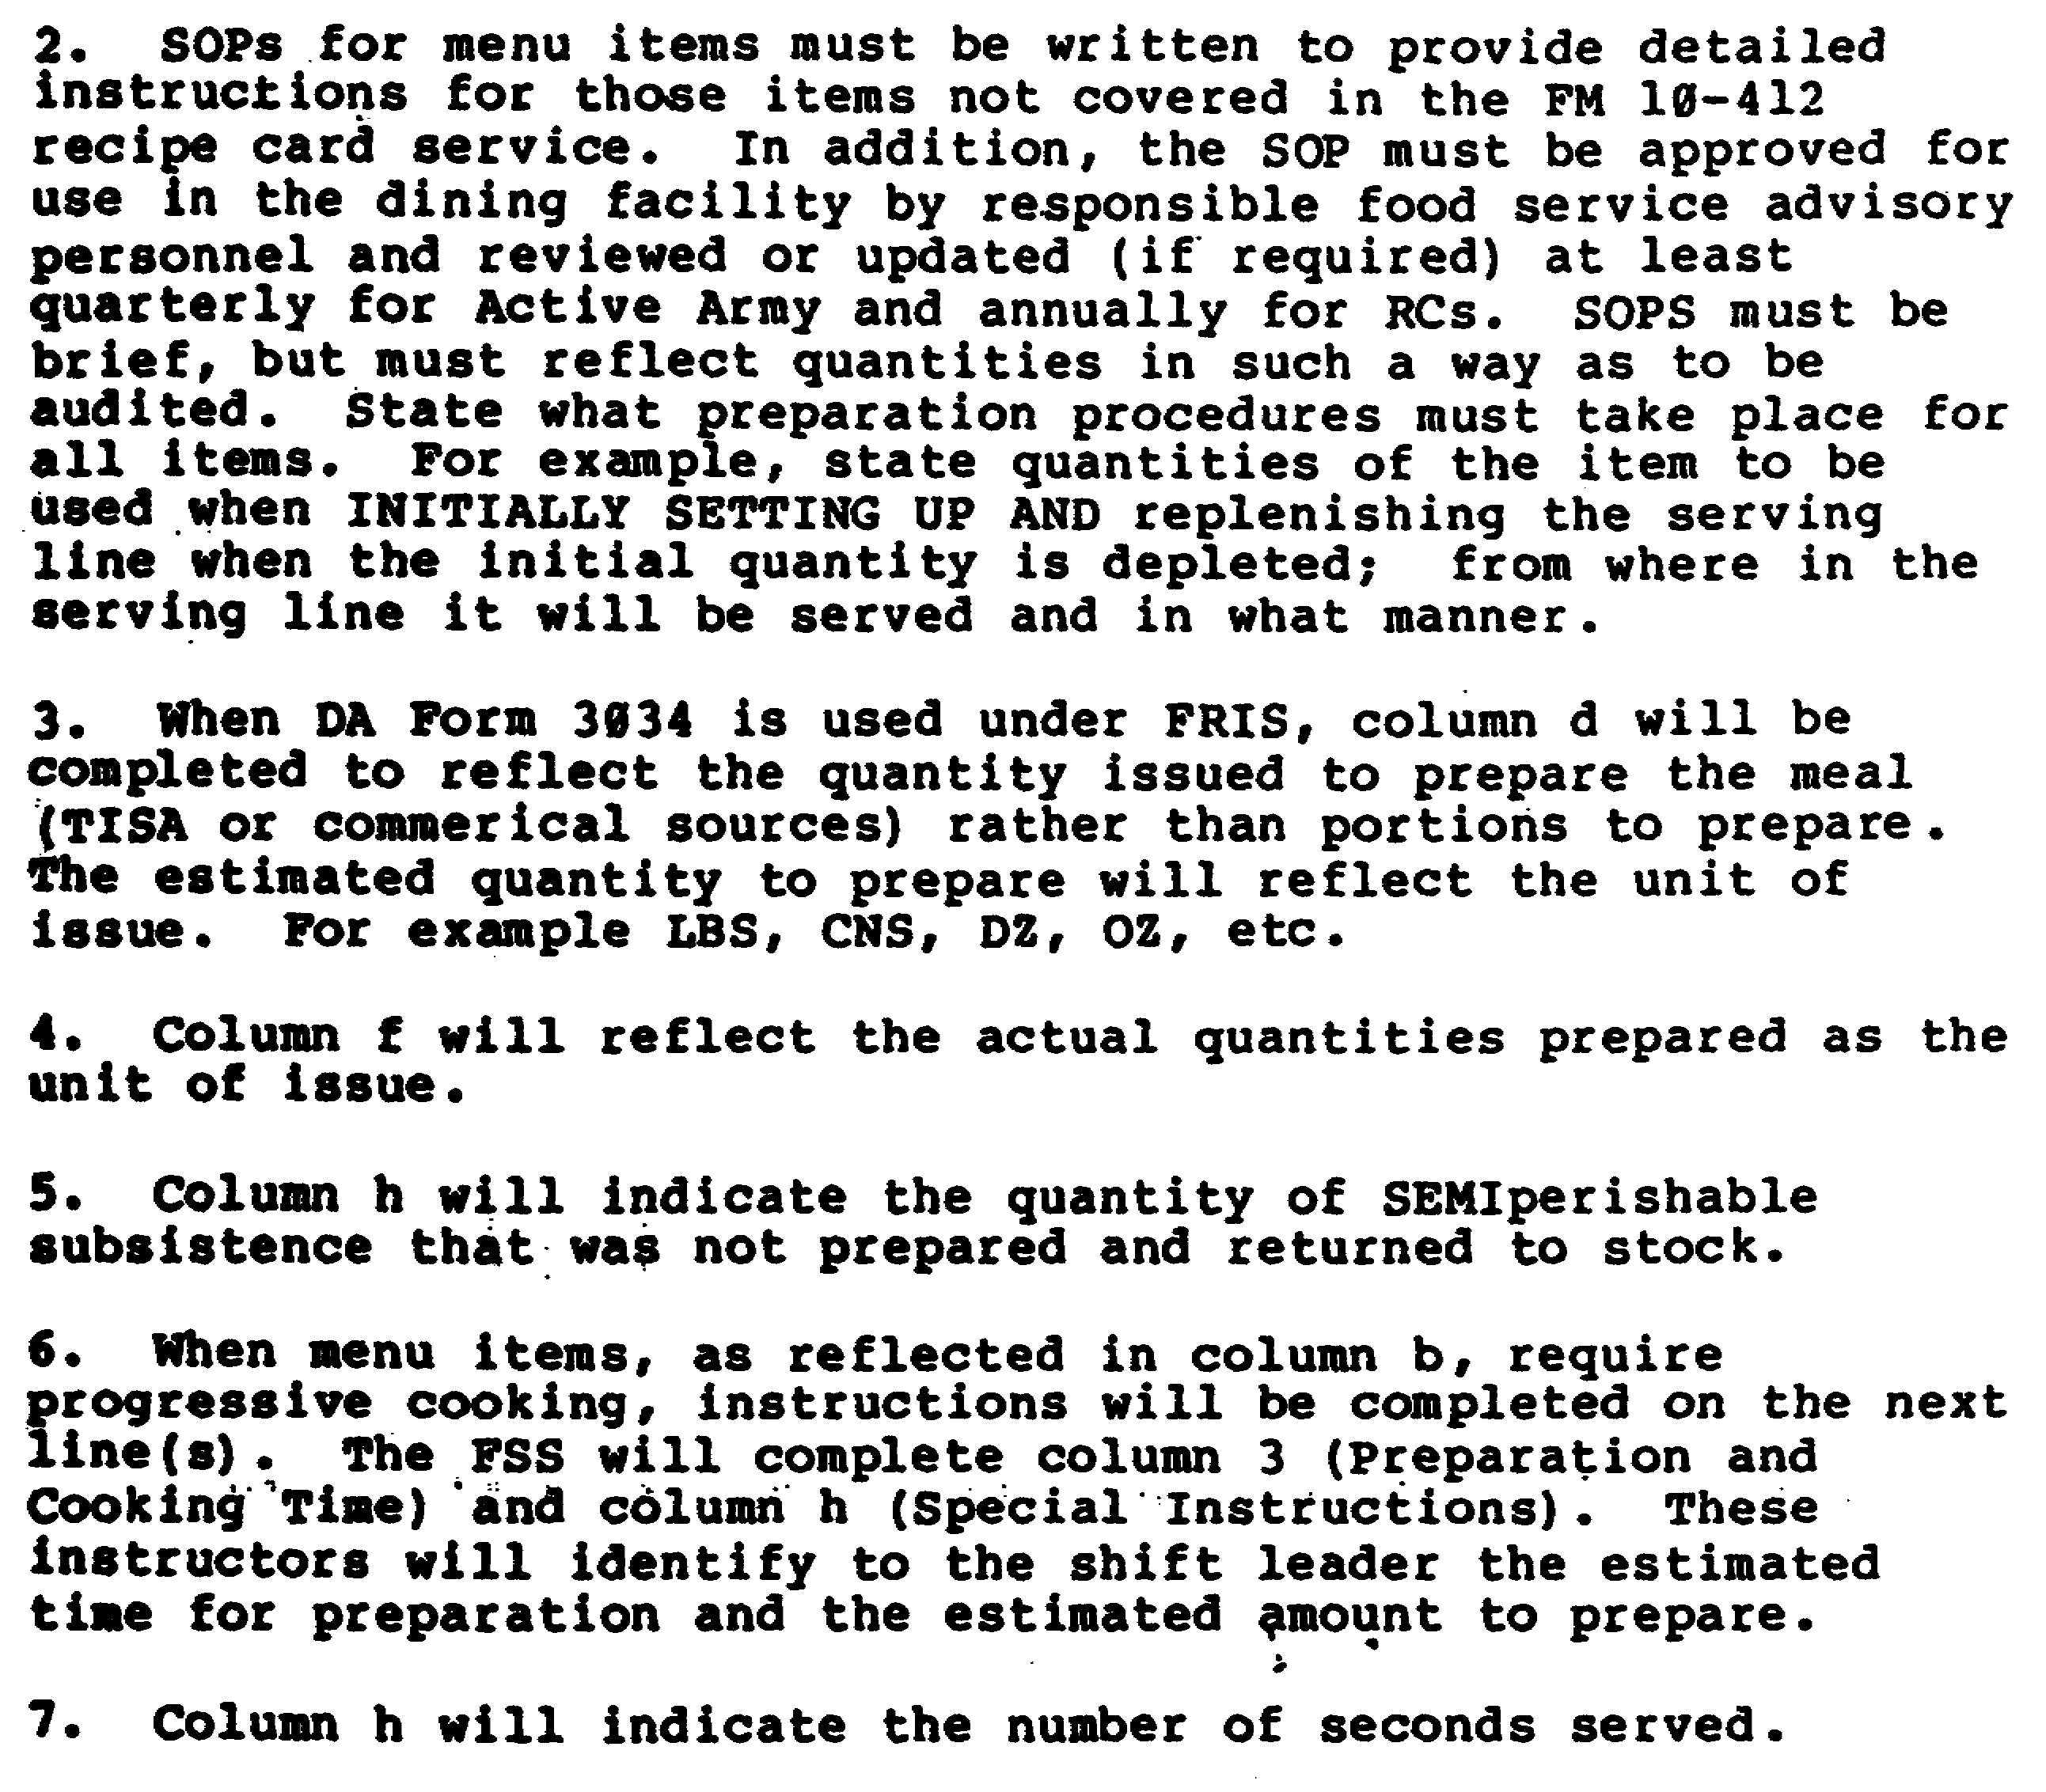

Figure 1a. Instructions for Completing DA Form 3034

4c

d. When commercially prepared meals are served to Reserve Component units during IDT, a production schedule is not required.

e. Instructions pertaining to preparation of box lunches will follow the same procedures, except that only columns a, b, c, d, e, and g are required to be completed on the DA Form 3034. Details are included in figure la.

3. MEASURING EQUIPMENT. Measuring equipment includes the measuring cup, measuring spoons, scales and dippers (figure 2). Scales are more exact than measuring utensils and should be used to weigh dry ingredients when possible. Liquid ingredients are usually measured using the standard measuring cup which holds one-half pint or 8 ounces; pint and quart measures are also used. There are lines (or subdivisions) marked on the cup for measuring one-fourth, one-half, three-fourths, one-third, and two-thirds of a cup. There ate also cups used for measuring less than a full cup, such as one-half cup measures or one-third cup measures. These cups give more accurate measurements than the standard measuring cup marked with subdivisions. Measuring spoons are also standardized. The spoons usually come in one tablespoon, one teaspoon, one-half teaspoon and one-fourth teaspoon sizes.

4. RECIPES. Recipes are tested to see if they are popular, as well as acceptable, before they are published as standard recipes by the Army. The Armed Forces Recipe Service (TM 10-412) is a file of 5x8-inch cards (figure 3) and a spiral bound index used by the Army, Navy, Air Force, and Marine Corps. The file has 17 sections, A through Q. Section A has general information, such as the meanings of cooking terms, conversion tables, measuring instructions, and tables of weights and measures. The other sections contain recipes which have been numbered and grouped according to type of food. At the start of each section is an index of the recipes that are in that section. The yield from these recipes is enough to serve 100 people. The master menu and the production schedule contain specific recipes (by number) from TM 10-412.

5. STEPS IN USING RECIPES. If a cook understands the recipes and uses them carefully, his/her cooking should always turn out well. The steps listed should be followed in using recipes:

a. Read the recipe. The cook should read all of the recipe and understand it before starting to prepare the food. He/she should look up the meaning of any new term, ingredient, or method.

5

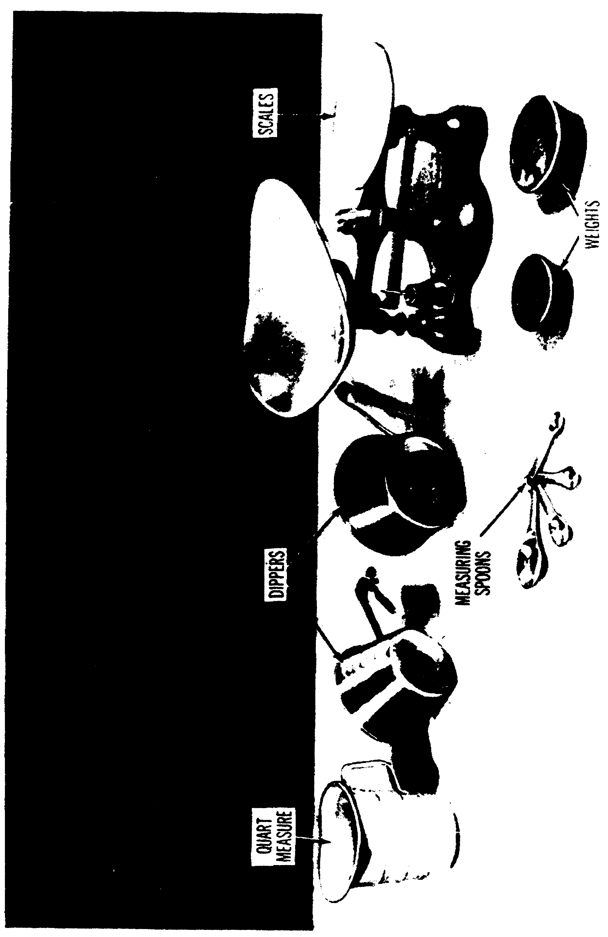

Figure 2. Measuring Equipment.

6

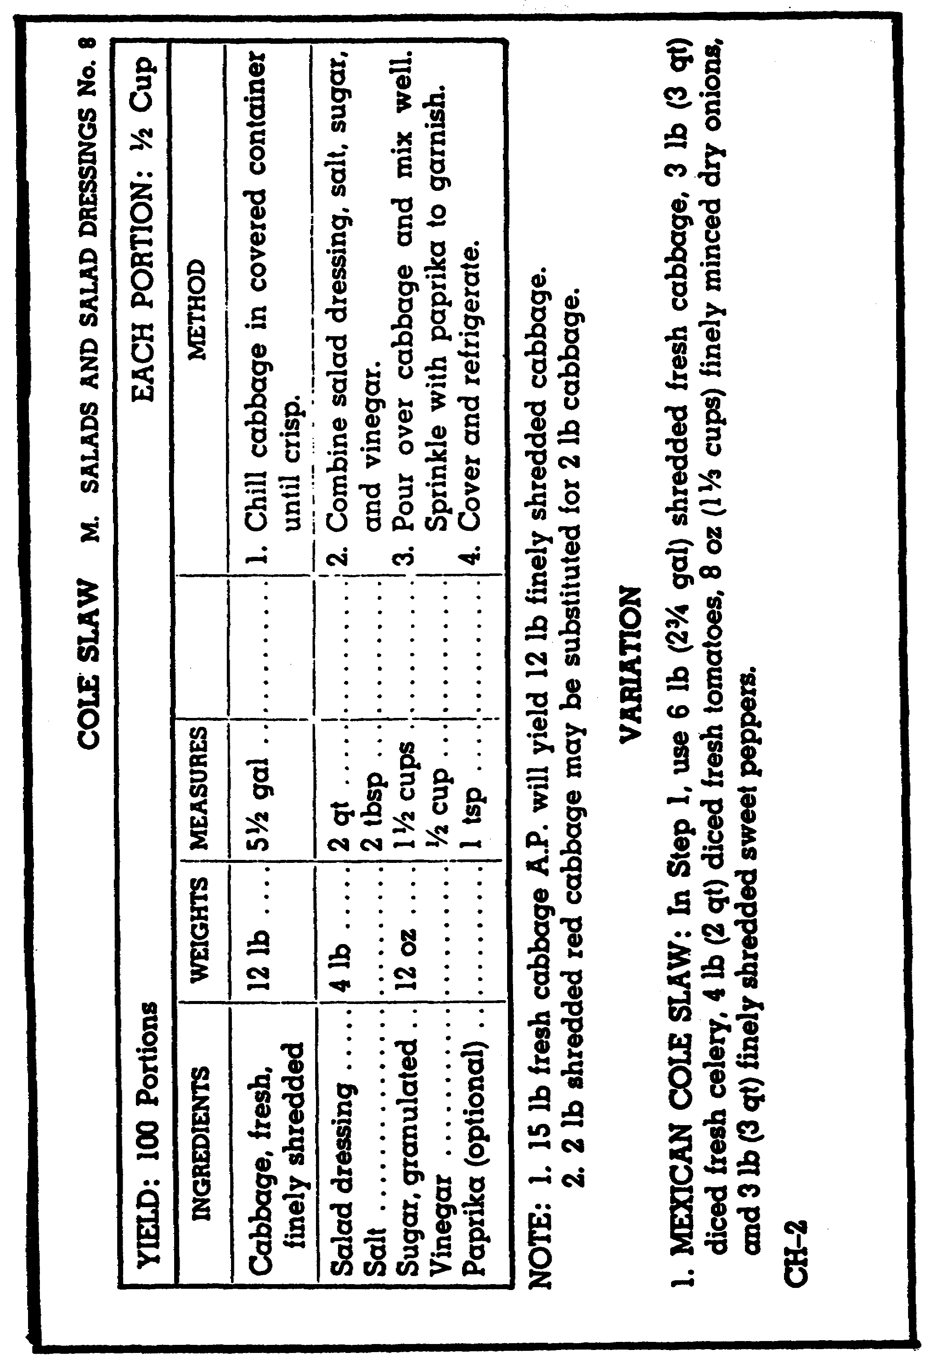

Figure 3. Sample recipe from Armed Forces Recipe Service (TM 10-412)

7

b. Assemble utensils and ingredients. The cook should gather together all utensils and ingredients called for in the recipe. The recipe will tell you the type of equipment needed (pans, casserole dishes, saucepans, skillets, and double boilers) and the sizes that are needed. The cook should measure the ingredients accurately.

c. Preheat oven or other equipment to be used. If the oven is to be used, it should be turned on and the heat control set for the right temperature. After the right temperature is reached, the oven should not be loaded for several minutes to allow time for the heat to build up and spread inside the oven. When preheating other equipment, always follow the directions of the company which made the equipment.

d. Mix ingredients. Ingredients should be mixed the way the recipe says to mix them. Even a small change in the recipe can make the difference between an outstanding dish and a failure. For example, if the recipe calls for whipping, the ingredients should be whipped, not stirred.

e. Observe cooking time and temperature. All recipes call for definite cooking times and temperatures that must be followed exactly for the best results.

f. Care of the finished product. It is important to be careful when handling food after it is cooked. Any directions for taking cakes out of pans, for taking gelatin salads or desserts out of molds, or for keeping foods hot or cold should be followed.

6. RECIPE CHANGES.

a. The cook may use more or less of the ingredients called for in the recipe, but all ingredients must be increased or decreased by the same amount. Recipes are planned to yield 100 portions, but there are recipe conversion instructions in Section A, General Information, of TM 10-412, since few dining facilities serve exactly 100 portions (Appendix E). There also may be a slight difference in the cooking time of food because of changing the amounts. If a larger amount is placed in one pan, the cooking time could be longer, for example, when cooking a thicker slice of meat or a larger size of potatoes.

b. Variations or changes in ingredients are listed at the end of many recipes in TM 10-412 so that a product can be made that is slightly different from the original (fig. 3). Other changes in the basic recipe should be made only by an experienced cook, but only when he/she knows that the people who will eat the food will like the changes.

8

7. METHODS OF MIXING INGREDIENTS. There are four methods of mixing ingredients. The mixing method specified in the recipe must be used; if one method is substituted for another, the results may not be satisfactory.

a. Stirring. Stirring is mixing ingredients with a circular motion until they are well blended. Mechanical mixers are useful for mixing large batches.

b. Beating. Beating is moving a spoon in a rapid over-and-under circular movement in order to incorporate air. Stirring does not incorporate the air into the food. Products can also be beaten in a mixing machine with the beater accessory.

c. Whipping. Whipping is combining ingredients rapidly with a wire whip to increase volume by incorporating air. Products can be whipped with a wire whip or in a machine with the wire whip accessory.

d. Folding. Folding is incorporating a food ingredient (such as whipped cream or beaten egg whites) into a mixture with a cutting or over-and-under motion to preserve the air bubbles.

8. TEMPERATURE CONTROL. Temperature control has an effect on the finished food product. The exact cooking temperature which the recipe says to use should be carefully followed. If the equipment to be used does not have a thermostat, then the right kind of thermometer should be used.

a. Oven thermometers. Most Amy ranges have thermostats that control the oven temperature and let foods cook at the same heat all the time the food is cooking. If a range does not have a thermostat, an oven thermometer (figure 4) is used.

b. Deep-fat thermometers. A deep-fat thermometer is the best kind of thermometer to use for deep-fat frying. This thermometer shows when fat has reached the right temperature for cooking the food you want to cook. It also shows the temperature of the fat for all the time the food is cooking, which is important because the fat should be at the same temperature all the time while deep-fat frying. This thermometer should be clipped to the side of the deep-fat fryer with the bulb below the surface of the melted fat, but not touching the bottom of the container. Your eye should be on the same level as the top of the mercury column when reading the scale.

9

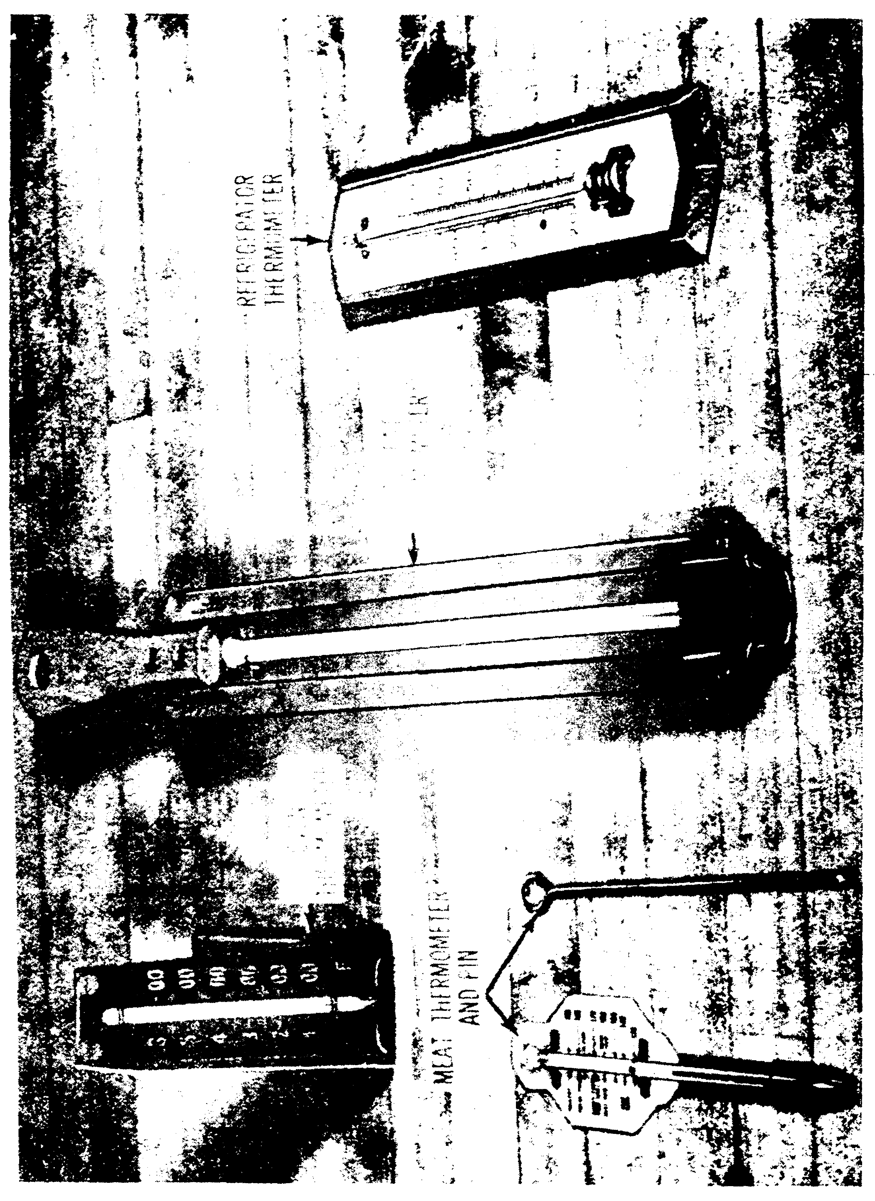

Figure 4. Thermometers used in the Army

10

c. Meat thermometers. The best way to see when a roast or turkey is done is to use a meat thermometer (figure 4). When it is cooking, meat gets hot on the outside first and slowly heats to the center of the meat. When the center of the meat reaches the temperature called for in the recipe, then the meat has been cooked to the right degree of doneness called for in the recipe. The thermometer should be put in the thickest part of a roast or in the thigh of a turkey. The point of the thermometer should be kept away from fat pockets and bone. A lot of fat around the point of a thermometer may cause a wrong temperature reading because fat may trap a lot of heat around the thermometer. Bone does not hold heat very well, so if the temperature bulb rests against a bone there may be a wrong temperature reading.

d. Refrigerator thermometer. A refrigerator thermometer (figure 4) is hung on the wall of each walk-in refrigerator to show the right temperature for that refrigerator and to keep the temperature the same at all times.

9. WASH HANDS BEFORE HANDLING FOOD PRODUCTS. Remember to wash hands with hot water and soap or detergent before working. Also wash after using the latrine, after use of any tobacco or at any other time when the hands are dirty.

10. ASSEMBLE ALL THE INGREDIENTS. Before beginning the item that is to be prepared, first gather all the ingredients. This should include all non-perishable items, all perishable items, and all seasonings. This is done to make sure that the menu item you are preparing can be prepared because all the ingredients are present.

11

REVIEW EXERCISE

The questions in this review exercise give you a chance to see how well you have learned the material in lesson 1. The questions are based on the key points covered in the lesson.

Read each item and write your answer on the line or lines provided for it. Please use a pencil to write your answers. If you do not know, or are not sure what the answer is, check the paragraph reference that is shown in parentheses right after the item; then go back and study or read once again all of the referenced material and write your answer.

After you have answered all of the items, check your answers with the Solution Sheet at the end of the Review Exercise. If you did not give the right answer to an item, erase it and write the correct solution in the space instead. Then, as a final check, go back and restudy the lesson reference once more to make sure that your answer is the right one.

A1. List the four objectives of good food preparation. (para 1a-d)

REQUIREMENT: Exercises A2 through A6 are in scrambled order. They are all the steps followed in the preparation of a standard recipe. Put them in the order in which they would be performed. Indicate your answer by putting a in front of step 1, b in front of step 2, and so forth.

A2. Assemble utensils and ingredients.

A3. Mix ingredients.

A4. Read the recipe.

A5. Preheat oven or other cooking equipment used.

A6. Follow cooking time.
(para 5a-e)

12

REQUIREMENT: Exercises A7 through A10 cover the types of thermometers used in food preparations. Identify each by filling in the blank.

A7. If a range does not have a thermostat, a(n) ______________________ thermometer is used. (para 8a)

A8. A thermometer which is clipped to the side of the deep-fat fryer is a(n) _________________ thermometer. (para 8b)

A9. The best way to tell when a roast or turkey is done is to use a(n) ________________ thermometer. (para 8c)

A10. The temperature of each walk-in refrigerator is controlled by hanging a(n) ___________________ thermometer on the wall. (para 8a)

DO YOU UNDERSTAND EVERYTHING IN THIS REVIEW EXERCISE? HAVE YOU CHECKED YOUR RESPONSES, MADE CORRECTIONS, AND RESTUDIED THE TEXT, IF NECESSARY? IF YOU HAVE, GO ON TO THE NEXT STUDY UNIT OF THIS SUBCOURSE.

13

EXERCISE SOLUTIONS

EXERCISE SOLUTION

A1. -Conservation of nutritive value.
-Improvement of digestibility.
-Enhancement of flavor and
attractiveness.
-Making food safe for human
consumption.

A2. b

A3. d

A4. a

A5. c

A6. e

A7. oven

A8. deep-fat

A9. meat

A10. refrigerator

14

LESSON 2

OBJECTIVE TASK No. 101-524-1152. Prepare and cook meat, poultry, and seafood.

TASK: When you successfully complete this assignment, you will be able to prepare and cook meat, poultry, and seafood. This includes the following performance measures:

1. Measure or weigh each ingredient, using measuring spoons, a scale, a quart dipper, or a measuring cup.

2. Process ingredients for use by following the procedures listed in the method column on the recipe card.

3. Combine ingredients by blending, mixing, folding, Whipping, or stirring.

4. Make-up ingredients into serving portions when needed.

5. Place meat, poultry and seafood in pans.

a. Select pans required by the cooking method.

b. Prepare pans for use.

c. Arrange items in pans and refrigerate pans until ready for cooking, unless items are to be cooked immediately.

6. Start cooking process.

a. Apply dry-heat cooking methods.

b. Apply moist-heat cooking methods.

15

7. Check progress of items while they are cooking.

a. Read thermometer.

b. Twist leg of poultry to determine doneness.

c. Flake fish with fork.

8. Cook foods for periods of time shown on the recipe card or until test reveals item is done.

CONDITIONS: You are a cook assigned to a garrison dining facility or a field kitchen. Your name has been entered on the production schedule assigning you to prepare and cook a meat, poultry, or seafood item. For evaluation, you will be given a situation requiring you to complete selected performance measures. This task is performed in a garrison dining facility or in a simulated combat situation under all environmental conditions.

CREDIT HOURS: 1

REFERENCES: TM 10-412, Armed Forces Recipe Cards FM 10-25, Preparation and Serving of Food in the Garrison Dining Facility

16

LESSON TEXT

SECTION I

MEAT

1. TYPES OF MEAT USED IN THE ARMED FORCES. Many kinds of meat are used in the Armed Forces, such as fresh, variety, prepared, cured or smoked meats, and dehydrated meats.

a. Fresh meats. Some kinds of fresh meat served to Armed Forces personnel are beef, veal, lamb, and pork. The meats are usually frozen and cut up or boned before coming to the Army with normal issues of food.

(1) Beef. Beef cuts come to the Amy in the form of steaks, oven roasts, swiss steaks, pot roasts, diced beef, and ground beef. Ground beef comes in either bulk or formed patties. Figure 1 shows cuts of beef as given by USDA. Beef may be served rare, medium, or well done.

(2) Veal. Veal is the flesh of young calves. Veal has a higher water content than beef, and it is lower in fat and extractives. Veal is served well done; all veal is classed as tender meat.

(3) Lamb. The biggest difference between lamb and beef is lamb's special flavor which is caused by the kind of fat in lamb. The flavor is very mild in lambs but it becomes stronger as the animals get older. When lamb meat is taken off the heat, the fat becomes thick very fast because it has a high melting point. Most lamb is served well done, but lamb chops are sometimes served medium done.

(4) Pork. Pork contains a lot of fat. Even though much of the fat is on the outside of the meat and is cut off before cooking, most lean pork has more fat than other kinds of meat. Fresh pork and pork products must always be cooked to a minimum internal temperature of 150°F so that those who eat the pork will not become ill with trichinosis. However, 1700F is recommended for best flavor.

b. Variety meats. Liver, heart, kidney, sweetbreads, tripe, brains, and tongue are called variety meats, even though they are really fresh meats. Only beef liver and chitterlings are served to the Armed Forces.

c. Prepared meats. Some kinds of prepared or ready-to-serve meats which the Armed Forces gets for their personnel are luncheon meats, frankfurters, and different types of sausages.

17

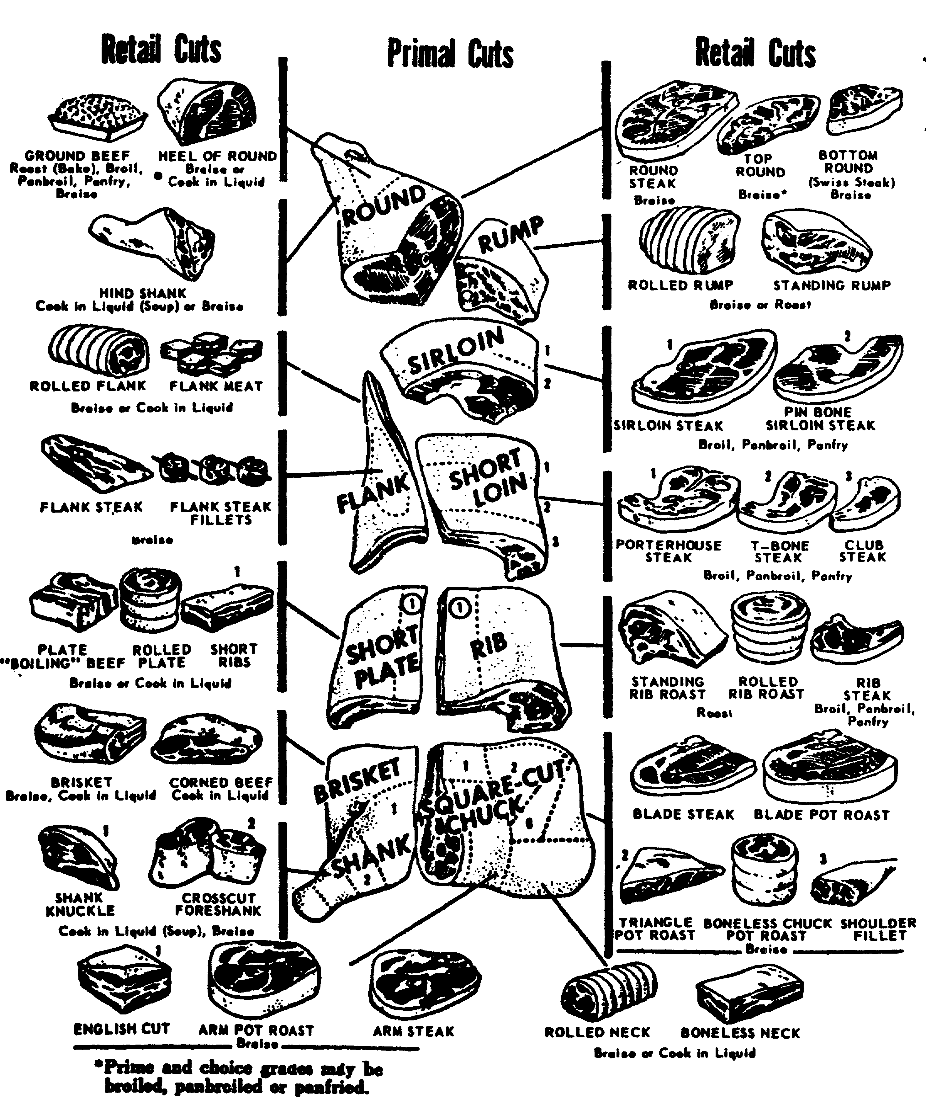

FIGURE 1

18

d. Cured and smoked meats. Cured meats are those meats, such as corned beef, that have been salted or made ready for use in the future in some other way. Some kinds of smoked meat are ham and bacon, which come from pork, and dried beef. Most dried beef is smoked, but some is only cured.

e. Dehydrated meats. Several meat products processed by freeze dehydration, such as beef patties, beef steaks, pork chops, and chicken, are used in the B rations, and may be included in the A ration when stocks on hand are to' be rotated.

2. GUIDELINES FOR HANDLING AND COOKING MEATS. Meat must be refrigerated as soon as it comes to the kitchen or dining facility. Most of the time, frozen meat is thawed before it is cooked so that it will not take so long to cook. Most recipes from the Armed Forces Recipe Service give cooking times for thawed meat. If you must start cooking some meat while it is still frozen or almost frozen, you can cook it by lowering the temperature of the oven and cooking the meat for a longer time. Frozen meat should be thawed in a refrigerator and there should be enough room between the pieces of meat so that air will be able to circulate between them. Meat must be covered if it is to stand for more than a few minutes out of the refrigerator before it is cooked. Meat is cooked so that it will taste better and have better color and texture, and to kill any germs in the meat. When cooking meat, it is important to use the right cooking method, the right seasonings, and the right oven temperature. The best way to cook a piece of meat will depend on many things: the total weight of the cut of meat, its outside area and the shortest distance to the center of the thickness, the amount of cooking that is wanted (well done, medium, or rare) and on the type of meat (fat or lean). The two ways of cooking meats are the dry-heat and the moist-heat methods.

3. DRY-HEAT METHODS. Cooking with dry heat means cooking with no liquid except grease. Dry heat is best for cooking tender cuts of meat. Some dry-heat methods of cooking are: roasting, baking, grilling, deep-fat frying, and frying.

a. Roasting and baking. Most unsmoked meats cooked in the oven by dry heat are said to be roasted; smoked ham and ground meats cooked by dry heat are said to be baked. Meat for roasting is cut into 6- to 8-pound pieces and placed in a shallow pan which will give an even spreading of heat over a bigger part of the outside of the roast. Fresh pork, lamb, and veal may also be roasted. When it can be done, the roast should be placed on a rack that fits in the pan. The fat side of the meat should be placed facing up in the pan so that the fat will flow over the meat, baste it, tenderize it, and add richness, flavor, and moisture to it. Each roast should be rubbed with salt and pepper, and

19

with any other seasoning which the recipe says should be added before cooking. The meat thermometer should be put into the center of the thickest part of the meat. The temperature reading will be wrong if the thermometer point rests against a bone or is put into a pocket of fat. Bone does not hold heat very well, so if the thermometer rests against a bone the temperature reading will be lower than the real temperature of the meat. If the thermometer is put into a pocket of fat, the temperature reading may be higher than the real temperature of the meat because fat traps a lot of heat around it. Roasts should be taken out of the oven before the meat temperature you want is reached because the temperature inside the meat will keep on going up for 15 to 20 minutes after the roast is taken out of the oven. The internal temperature can rise as much as 5° to 10°F for some sizes of roasts. It is easier to carve roasts into servings of the same size if you first let the meat set from 20 to 30 minutes after it is taken out of the oven. Carving is easier if you first learn something about the way the bones, fat, and such are arranged inside the meat. The right tools must be used, and they must always be well cared for. Roasts should be trimmed in the kitchen, not on the serving line. Meat should be carved across the grain and away from the carver. The servings of meat should be stacked so that they can be taken off the stack on the serving line without breaking up the meat. The working area and the cutting board must be kept neat and clean.

b. Grilling. Chops or steaks are made ready for grilling by scoring (cutting) only the fat edges in a few places to keep the meat from curling. Meat should not be salted before grilling because salt dries out the inside of the meat and makes it harder for the meat to brown. Grilling is done on a medium hot, greased griddle. Chops, steaks, and patties of ham, veal, beef, lamb, and fresh pork are usually grilled.

c. Deep-fat frying. Meat is deep-fat fried by covering it with a coating, such as bread crumbs, and then covering it in medium fat, 3500F to 3750F. The pieces of meat must be small enough so that they will cook by the time they are brown. Recipes for deep-fat frying meats should be followed.

d. Frying. To fry meat is to cook it slowly, uncovered on top of the range in a small amount of fat (just enough to keep the meat from sticking or burning). Meat for frying is thinly sliced. Cook it at a moderate temperature and turn it occasionally. Some recipes call for the meat to be rolled in seasoned flour before it is fried.

4. MOIST-HEAT METHODS. Moist heat, which means cooking with liquid other than grease, is used for all less tender cuts of meat because moist heat will make the meat more tender. When using moist heat, the meat should be seasoned while cooking because the seasoning will cook into the meat and bring out the flavor. Stewing and braising are the most common methods of moist-heat cooking.

20

a. Stewing. Meat is stewed by covering it and simmering (not boiling) it in a liquid on top of the stove just below the boiling point at a temperature of 180°F to 2100F. Cooking at a boiling temperature will make the meat tough and will reduce the flavor, the nutrition, and the shape of the meat. The liquid in which meat has been cooked is called a stock. More liquid is used for stewing than for braising. Beef, veal, lamb and smoked ham are often stewed or simmered.

b. Braising. Meat is braised when it is browned in a small amount of fat, a small amount of water is then added, and the meat is cooked slowly in a covered container on top of the stove, or in the oven, or in a steam-jacketed kettle. The recipe may or may not call for the meat to be rolled in seasoned flour before it is browned. There are different kinds of braised meats; one kind is the pot roast, a large, less tender cut of beef, veal, or lamb that is cooked by braising; another kind of braised meat is the swiss steak made from beef.

5. COOKING TEMPERATURES AND DEGREE OF DONENESS. Oven temperatures are controlled by regulators or thermostats so that meat can be cooked in the oven at even temperatures. If the range does not have a regulator, an oven thermometer is used. The meat cooking time given in a recipe may depend on the cooking temperature and the time (in minutes) to cook for each pound of meat, or cooking time may depend on the cooking temperature and the temperature inside the meat as measured by a meat cooking thermometer which has been put into the cut. If you can do so, always use the meat thermometer. Low temperature cooking usually means that there will be a smaller cooking loss in the size of the meat, the meat will have more juice, the meat will cook evenly, and there will be a longer cooking time. Most of the time, meat cooked at a low temperature does not brown as much as meat cooked at a high temperature. You can tell how long a cut of meat has been cooked by the color of the extractive. The extractive is a dense substance with a lot of flavor which comes out of the meat while it is cooking; the extractive has soluble (can be dissolved) proteins, vitamins, minerals, nutrients, and liquid fat. The color of the extractive from rare meat is reddish, from medium meat is pink, and from well done meat it is gray or brown. The higher the temperature at which meat is cooked, the more the meat will shrink.

6. CANNED MEATS. Canned meat, such as beef and gravy, ham chunks, pork and gravy, or corned beef, can be made into very nutritious and tasty dishes. Recipes in TM 10-412 tell how to get canned meats ready for cooking and how to use them in place of fresh meats. Meats such as beef and gravy or pork and gravy should be defatted before mixing them with other foods. This defatting can be done by placing the can of meat in boiling water for about 20 minutes, or by opening the can and heating the meat in a pan in the oven. The liquid fat is then drained off and may be used in sauces or in other dishes.

21

7. DEHYDRATED MEATS. These meat products include uncooked beef patties; uncooked diced beef; uncooked beef steaks; and uncooked pork chops. The meats may be rehydrated in advance of cooking time and kept in the refrigerator or they may be cooked immediately after rehydration. The meats must be rehydrated as soon as the cans are opened. All are rehydrated by soaking in salted water, but the temperature of the water to be used and the rehydration time vary with the product. After the pieces of meat have been soaked until no hard spots remain, they are drained and placed in a covered container. Some of the cooking methods for dehydrated meats follow:

a. Beef patties. Brown rehydrated patties on a hot greased griddle and serve them with gravy or baked in a sauce or gravy.

b. Beef steaks. Rehydrated beef steaks can be served as swiss steak. Brown the steaks on a hot greased griddle and place them in a roasting pan. Pour tomato sauce over the steaks and bake them in a moderate oven for 1 hour.

c. Pork chops. Dip rehydrated pork chops in a mixture of bread crumbs, flour, and seasonings and then lightly brown them on a hot greased griddle. They may be served with a cream gravy.

22

REVIEW EXERCISE A

The questions in this review exercise give you a chance to see how well you have learned the material in section 1 of lesson 2. The questions are based on the key points covered in the section.

Read each item and write your answer on the line or lines provided for it. Please use a pencil to write your exercise. If you do not know, or are not sure what the answer is, check the paragraph reference that is shown in parentheses right after the item; then go back and study or read once again all of the referenced material and write your answer.

After you have answered all of the items, check your answers with the Solution Sheet at the end of this exercise. If you did not give the right answer to an item, erase it and write the correct solution in the space instead. Then, as a final check, go back and restudy the lesson reference once more to make sure that your answer is the right one.

A1. The meat cooking method which uses no liquid other than grease is called the _________________ method. (para 3)

A2. The meat cooking method which uses liquid other than grease is called the __________________ method. (para 4)

REQUIREMENT. Exercises A3 through A8 describe the methods of cooking meat used in the garrison dining facilities. Listed below are meats served in the garrison dining facility. Put the letter of the meat beside the method that may be used to cook it. Each meat may be cooked by one or more than one method.

a. Beef.
b. Fresh pork.
c. Ham.
d. Veal.
e. Lamb.

A3. Roasting, a dry-heat method of cooking In the oven. (para 3a)

A4. Baking, a dry-heat method of cooking in the oven. _________________ (para 3a)

A5. Grilling, a dry-heat method of cooking on a lightly greased griddle. ___________________ (para 3b)

A6. Frying, a dry-heat method of cooking meat in a small amount of grease, uncovered, on top of the range ___________________. (para 3d)

23

A7. Stewing, a moist-heat method of cooking less tender cuts of meat, covered, on top of a range. ____________________ (para 4a)

A8. Braising, a combination of dry-heat and moist-heat cooking methods, used for less tender cuts of meat. _____________________ (para 4b)

DO YOU UNDERSTAND EVERYTHING IN THIS REVIEW EXERCISE? HAVE YOU CHECKED YOUR RESPONSES, MADE CORRECTIONS, AND RESTUDIED THE TEXT, IF NECESSARY? IF YOU HAVE, GO ON TO THE NEXT STUDY UNIT OF THIS SUBCOURSE.

24

EXERCISE A SOLUTIONS

Exercise Solution

A1 dry-heat
A2 moist-heat
A3 a, b, d, e
A4 c
A5 a, b, c, d, e
A6 a, b, c, d, e
A7 a, b, d, e
A8 a, b, d, e

25

SECTION II

POULTRY

8. TYPES OF POULTRY SERVED TO THE ARMED FORCES. Poultry is an important part of the military diet because it has a lot of proteins, minerals, and vitamins. Two types of poultry served are turkey and chicken.

a. Turkeys. Most of the time, turkeys come to Army kitchens frozen, whole eviscerated (with the inner organs already taken out), and ready for cooking. The giblets, which are the liver, gizzard, and heart, and the neck are wrapped in suitable paper and frozen in the hollow space inside the bird. Even though turkeys are sold in many different sizes from young broilers to old hens and toms, only young birds are issued for the troops to eat. These birds weigh from 16 to 23 pounds and include toms and hens less than 1 year old.

b. Chickens. Broiling and frying chickens are received frozen and eviscerated. They may be whole or cut up. Roasters are usually received whole, frozen, eviscerated, and ready for cooking.

9. GUIDELINES FOR SELECTING AND HANDLING POULTRY. Selecting the best poultry for cooking depends on many things: the age of the flesh and how tender it is; the amount of fat (some but not too much fat); no strange coloring in the chicken; and a soft skin that can be bent easily. Young birds have flexible (soft and can be bent) breastbones; older birds have hard breastbones. Not only do birds look better if their skin is not broken, but broken skin shortens the time the bird can be safely stored and will cause the loss of juices and flavors when the bird is cooked. Like most protein foods, poultry can spoil very easily, and so it should be kept in the refrigerator at a low temperature, 32° to 42°F. Poultry that has been taken out of the freezer should be used in 24 hours or less. Once poultry has been thawed, it should never be refrozen. Hard frozen poultry that has been wrapped in suitable paper may be kept in the refrigerator for about 3 days at temperatures between 32° and 40°F. Enough time should be given for the frozen poultry to thaw slowly in the refrigerator before the time of the meal at which the poultry will be served. If possible, the birds should be separated, placed on trays, and set on shelves in the refrigerator to let the air circulate around them; but if the turkeys cannot be thawed all the way before cooking, they can be cooked by keeping them in the oven for a longer cooking time at a lower temperature.

26

10. COOKERY. Many of the rules followed in cooking poultry are the same as the rules for all other meat cookery. No matter what the type or age of the poultry, medium heat should be used for all birds for the best flavor, tenderness, color, and juiciness. High heat makes the proteins in the meat hard and tough, it makes the muscles smaller, and it dries out the meat. The dry-heat methods of frying and roasting are used for young, tender, fat chickens. Turkeys are cooked by the dry-heat method of roasting. Braising, which uses both dry and moist methods of cooking meats, is best for older, leaner chickens that are not tough enough to need stewing. Both chickens and turkeys are sometimes cooked by moist-heat, not so much to make the meat more tender as to have a change in the menu. The meat may be creamed or used in pot pies, in chow mein, or in salads.

11. DRY-HEAT COOKING. Frying, baking, and roasting are the dry-heat methods used in the dining facility for cooking poultry. Chicken may be fried or baked, while turkey is roasted only.

a. Roasting. The way to get a turkey or a chicken ready for roasting or baking is the same for both birds. The main difference in roasting a turkey or baking a chicken is the longer cooking time which the turkey needs. Get a turkey ready for roasting by removing the giblets from inside the bird, plucking the pinfeathers, and washing the bird inside and out under cold water. The turkey is then dried with a clean cloth or paper towel, and the hollow space (cavity) inside the bird is rubbed with a small amount of salt and pepper. The loose skin is pulled back over the back bone and the wings are folded over it to keep the neck piece in place. The ends of the legs are put through the band at the end of the bird. If the band is broken, the bird is tied or wired and made as compact as it can be made. The bird is then brushed with melted fat or oil and placed in a shallow, uncovered roasting pan, breast side up. A rack on the bottom of the roasting pan will give more protection and better circulation of hot air. The bird is placed in an oven heated to 325°F and basted now and then with melted fat. If butter is used for basting the bird, you must be careful not to let the meat get too brown. Roast the bird until it is tender and the breast is golden brown. A sheet of aluminum foil may be placed loosely over the bird so that it will not get too brown. If the foil is wrapped tightly, there will be a lot of steam trapped around the bird; the steam will change the cooking method from dry heat to moist heat and take away from the true flavor of the meat.

(1) Poultry dressing. The important ingredients of a poultry dressing are a starch base such as day-old bread or rice; seasonings such as celery, onions, or peppers; a fat in some form; and chicken or turkey stock. The vegetables are sauteed (fried quickly in a pan with a little fat) and mixed with the bread, and the stock is added. The mixture is formed into patties and baked, or it is put in pans and baked and then cut into squares or serving pieces when done. The dressing should be moist but not soggy.

27

(2) Methods to determine doneness. There are three ways used to tell the doneness of poultry. A meat thermometer may be used with turkey. The thermometer is put into the thickest part of the thigh, away from the bone. The turkey is done when the thermometer reads 1850F. Chicken and turkey may be tested by twisting the leg bone toward the body of the bird. If the leg bone moves or separates in the joint between thigh and drumstick, the bird is done. The time-weight ratio may be used with both turkey and chicken. The minutes cooked for each pound are multiplied by the weight of the bird. This ratio gives the total number of minutes for roasting a thawed bird at 325°F. If it is not thawed all the way before cooking, the cooking time will be longer.

(3) Carving. Good carving comes with practice and a sharp carving knife. The bird should be cooled a little before carving so that the juices will not be lost and there will not be a lot of crumbling. The bird is placed on its back with the legs to the carver's right or toward the carver. The drumstick is held firmly with the thumb and forefinger, and the skin is cleanly cut between the leg and body. With a little twist on the end of the drumstick, the leg may be separated from the body. The rest of the skin between the leg and back is cut. The leg and thigh are then separated and the meat is sliced. The wing is removed from the same side in the same way as the leg. When slicing the breast, the carver steadies the turkey by holding it with a carving fork across the ridge of the breast. Holding the knife parallel to the breastbone, he/she begins to slice just above the place where the wing was removed, each time carving higher until the top of the bone is reached. After the bird has been carved on one side, it is turned over, and carving is done in the same way on the other side. Another way of slicing the breast of a turkey is to remove the breast in one piece and slice it on the slicing machine. This is the best way of slicing when there are several birds to be carved. Turkey should not be carved too far ahead of serving time so that the slices do not dry out and lose their flavor and juices. Trays of sliced turkey to be served with cold cuts must be covered with a clean, damp cloth or other suitable covering and placed in the refrigerator.

b. Frying. Chickens should be cut into serving-size pieces before frying. The pieces are washed, drained well, and rolled in seasoned flour. They are then browned in a heavy frying pan which has about one-half inch of frying fat that has been heated to 365°F, or in a deep-fat fryer heated to that same temperature.

12. MOIST-HEAT COOKING. Braising and stewing are the moist-heat methods used in the dining facility for cooking all poultry not tender enough to be cooked by frying or roasting. Tender chickens are sometimes braised, not to tenderize them, but just to make a change in the menu. Chickens and turkeys that will be cooked by moist heat are usually quartered. Chickens may be braised by browning on top of the stove and then cooking with liquid in the oven. Turkeys and chickens

28

may be stewed for salads, pot pies, or a la king dishes. The pieces are placed In a stock pot with water, salt, and bay leaves, and the mixture is covered and brought to a boil. The heat is reduced, and the poultry is cooked until tender. The cooked meat is then put in the refrigerator. After the meat is cooled, it is cut away from the bones and then cut into pieces. The size of the pieces will be from 1/2 to 1 inch depending on the recipe. The stock is saved to use in sauces, soup, or gravy.

29

REVIEW EXERCISE B

The questions in this review exercise give you a chance to see how well you have learned the material in section II of lesson 2. The questions are based on the key points covered in the section.

Read each item and write your answer on the line or lines provided for it. Please use a pencil to write your answers. If you do not know, or are not sure what the answer is, check the paragraph reference that is shown in parentheses right after the item; then go back and study or read once again all of the referenced material and write your answer.

After you have answered all of the items, check your answer with the Solution Sheet at the end of this Review Exercise. If you did not give the right answer to an item, erase it and write the correct solution in the space instead. Then, as a final check, go back and restudy the lesson reference once more to make sure that your answer is the right one.

REQUIREMENT. Listed below in exercises B1 through B4 are methods used in the Amy dining facility for cooking poultry. Indicate which method is used for chicken or turkey, or both, by entering a for chicken and b for turkey in the spaces provided.

B1. Frying, a dry-heat method of cooking on top of the range. __________ (para 11)

B2. Roasting, a dry-heat method of cooking in the oven. _______________ (para 11)

B3. Braising, combination of dry-heat and moist-heat methods. The poultry is browned on top of the range by moist heat, then cooked in the oven by dry heat. _________________ (para 12)

B4. Stewing, a moist-heat method of cooking on top of the stove. _____ (para 12)

REQUIREMENT. Listed below in exercise B5 are steps taken in preparing poultry for roasting. Indicate the order in which these steps should be performed, rearranging the letters a through d as necessary.

B5. a. Dry bird well.
b. Rub bird with oil or shortening.
c. Remove neck and giblets from cavity; wash inside and out under running water.
d. Rub cavity with salt and pepper.

Correct sequence: ________________________ (para 11a)

30

REQUIREMENT. Listed below in exercise B6 are steps taken in carving a turkey. Indicate the order in which these steps should be performed, rearranging the letters a through e as necessary.

B6. a. Separate thigh from drumstick.
b. Place bird on back with legs toward carver.
c. Remove leg.
d. Remove wing.
e. Make cuts parallel to the breastbone.

Correct sequence: ________________ (para 11a(3))

DO YOU UNDERSTAND EVERYTHING IN THIS REVIEW EXERCISE? HAVE YOU CHECKED YOUR RESPONSES, MADE CORRECTIONS, AND RESTUDIED THE TEXT, IF NECESSARY? IF YOU HAVE, GO ON TO THE NEXT STUDY UNIT OF THIS SUBCOURSE.

31

EXERCISE B SOLUTIONS

Exercise Solution

B1 a
B2 a, b
B3 a, b
B4 a, b
B5 c, a, d, b
B6 b, c, a, d, e

32

SECTION III

SEAFOOD

13. CHARACTERISTICS. The word "seafood" as used in this subcourse will mean finfish, shellfish, fresh water fish, or salt water fish. Seafood is very perishable (it spoils very quickly) after it is removed from the water. Seafood must be cooked right away or stored properly as soon as it is received. Many of our military personnel do not like seafood, especially finfish, but this feeling is often due to too few changes in the seafood menu and poor preparation. The troops may like fried finfish, but they can get tired of it when it is served too often. Seafood is rich in proteins, and it can be baked, poached, fried, stuffed, or made into croquettes, casseroles, and salads. Seafood has less fat than meat and it is different in extractives, connective tissue, and color. Because it has less connective tissue than meat, seafood can be easily overcooked, which reduces its flavor and makes it less desirable to eat.

14. FINFISH. There are many kinds of finfish, such as salmon, mackerel, trout, flounder, haddock, bass, perch, cod, halibut, and shad.

a. Classes. Finfish are classified as lean fish or fat fish.

(1) Lean. Lean fish, such as haddock, flounder, halibut, and perch, have less than 5 percent fat. They are best when cooked by frying.

(2) Fat. Fat fish, such as the shad, salmon, tuna, and mackerel, have more than 5 percent fat. They are best when cooked by baking. The flesh of fat fish is more colorful than the flesh of lean fish.

b. Types served to military personnel. The two main forms of finfish served to military personnel are frozen and fresh fish.

(1) Frozen. The Armed Forces eat more frozen finfish than any other kind of fish because it can be handled, stored, prepared, and cooked easily. Frozen fish portions, which are breaded and ready for cooking; fish steaks, which are cross sections or cuts of a large dressed fish; and fish fillets, which are almost boneless, are served to military personnel. Fresh fish should cane to the dining facility in a frozen state with no signs of thawing and refreezing, and they should be kept solidly frozen until ready for use.

33

(2) Fresh. Fresh fish arrive packed in ice and must be used soon after arrival. They should have a bright appearance with bright, clear, full, bulging eyes. The scales should stick fast to the fish and the mouth and gills should be reddish pink and closed. Fresh fish sink in water. Stale fish have dull eyes and scales and soft flesh. The gills are usually pale pink. Stale fish have a bad smell especially on the inside, and they tend to float in water.

c. Cooking methods. Because fish does not have much connective tissue, a moist-heat method of cooking is not needed to make the fish more tender, but to make a change in the menu. The most common method of cooking finfish in the Army is the dry-heat method, such as in baking and frying.

(1) Baking. Fish of most sizes can be baked. Baking is the method used for cooking fat fish like mackerel because it brings out the flavor and a good color. The fish should be well cleaned and brushed on both sides with melted butter or margarine before being placed in the oven. The melted fat helps to keep the fish from drying out and will give it better flavor and color. Fish steaks and fillets should be cut into serving portions, placed skin side down in a lightly greased pan, and baked in an oven with a temperature of 375°F for 15 to 20 minutes, depending on how thick the pieces are. The fish may be covered with a sauce instead of butter during baking to help keep it from drying out.

(2) Panfrying. Small, whole lean fish or serving-sized pieces of steaks or fillets of lean fish are dipped into milk or an egg and milk mixture and then coated with a mixture of flour and salt and pepper, fine bread crumbs, or any other suitable breading material. The fish is then cooked in frying pans or roasting pans one-fourth to one-half filled with fat that is hot but not smoking.

(3) Deep-fat frying. Frozen breaded fish portions are not thawed before deep-fat frying because the breading may fall off if they are thawed. Frozen small, whole lean fish or serving-sized fillets and steaks of lean fish must be thawed, then dipped in an egg and milk mixture, drained, and rolled in a mixture of flour and bread crumbs.

d. Testing for doneness. The best way to test the doneness of finfish is the flake method. The fish is cooked enough when the layers of flesh tend to flake apart under slight pressure with a fork.

34

15. SHELLFISH. The two main kinds of shellfish served to military personnel are oysters and shrimp. Dry-heat or moist-heat methods of cooking may be used for both kinds.

a. Oysters. Oysters should be heated only to a serving temperature because they need no cooking to make them tender. Overcooking makes oysters tough. Oysters may be fried, baked, or used in oyster stews.

b. Shrimp. Overcooked shrimp are tough and shrunken. Shrimp are best when simmered in a stock that is seasoned with bay leaves, pepper corns, celery, and salt, or a prepared seafood seasoning. Shrimp are added to the boiling stock, simmered in a covered pot for 4 to 8 minutes, and then taken out of the stock right away so that the shrimp will not continue to cook. After they are shelled and have had the veins removed, shrimp may be placed in the chilled stock for a time to improve their flavor. Cooking directions on the package of frozen shrimp should be followed. Cooked shrimp can be used in salads, mixed with other foods in casseroles, served as an appetizer or cocktail with a spicy sauce, or dipped in a batter, breaded, and fried quickly.

16. CANNED OR PROCESSED SEAFOOD. Canned or processed seafood is served as a change in the Army menu. Several recipes are given in TM 10-412 for their use, including salmon cakes, salmon croquettes, salmon loaf, baked tuna and noodles, and tuna salad. Salmon must be drained, the skin and bones removed, and the meat flaked before it is mixed with other ingredients. Tuna must be drained and flaked.

35

REVIEW EXERCISE C

The questions in this review exercise give you a chance to see how well you have learned the material in section III of lesson 2. The questions are based on the key points covered in the section.

Read each item and write your answer on the line or lines provided for it. Please use a pencil to write your answers. If you do not know, or are not sure what the answer is, check the paragraph reference that is shown in parentheses right after the item; then go back and study or read once again all of the referenced material and write your answer.

After you have answered all of the items, check your answers with the Solution Sheet at the end of this exercise. If you did not give the right answer to an item, erase it and write the correct solution in the space instead. Then, as a final check, go back and restudy the lesson reference once more to make sure that your answer is the right one.

REQUIREMENT. Exercises C1 through C5 are matching exercises. Column I lists types of seafood. Column II lists methods of cooking. Match the seafood with the method or methods of cooking that may be used to prepare it. Each item in column II may be used once, more than once, or not at all.

COLUMN I COLUMN II

C1. Whole, fat fish or fat fish a. Baking.
steaks and fillets. (para 14c(l))
b. Stewing.
C2. Whole, lean fish or lean fish
steaks and fillets. (para 14c(2)(3)) c. Panfrying.

C3. Breaded fish portions. (para d. Deep-fat frying.
14c(2)(3))
C4. Oysters. (para 15a)

C5. Shrimp. (para 15b)

36

DO YOU UNDERSTAND EVERYTHING IN THIS REVIEW EXERCISE? HAVE YOU CHECKED YOUR RESPONSES, MADE CORRECTIONS, AND RESTUDIED THE TEXT, IF NECESSARY? IF YOU HAVE, GO ON TO THE NEXT STUDY UNIT OF THIS SUBCOURSE.

37

EXERCISE C SOLUTIONS

Exercise Solution

C1 a
C2 c, d
C3 c, d
C4 a, b, c, d
C5 b, c, d

38

LESSON 3

OBJECTIVE TASK No. 101-524-1158. Prepare and Cook Desserts Other than Pastries.

TASK: When you successfully complete this assignment, you will be able to prepare and cook desserts other than pastries. This Includes the following performance measures:

1. Measure or weigh each ingredient using measuring spoons, scales, a quart dipper, or a measuring cup.

2. Process ingredients for use following the procedures listed in the method column on the recipe card.

3. Combine ingredients by blending, mixing, folding, beating, stirring, and whipping.

4. Select appropriate preparation method.

a. Place ingredients in the proper equipment.

b. Select pans required by the cooking method.

c. Prepare pans according to the recipe cards.

d. Arrange ingredients in the pan.

5. Start cooking.

6. Cover items that require chilling or freezing with appropriate wrap, and place them in refrigerator or freezer. For soft-serve ice cream, pour mix into container in soft-serve ice cream machine and turn on machine.

7. Cook, chill, or freeze desserts for the periods of time listed on the recipe card or the mix container.

39

CONDITIONS: You are a cook assigned to a garrison dining facility or a field kitchen. You must now prepare and cook desserts other than pastries. This task is performed in a garrison dining facility or in a simulated combat situation under all environmental conditions.

CREDIT HOUR: 1

REFERENCES: TM 10-412, Armed Forces Recipe Cards
FM 10-25, Preparation and Serving of Food in the
Garrison Dining Facility

40

LESSON TEXT

1. GENERAL. The purpose of a dessert, either hot or cold, is to complete the main part of the meal and to round off the meal nutritionally. Desserts are sweet to the taste and add to the general enjoyment of the meal. Attractive desserts can give a needed change and interest to a meal that is dull in other ways. They can add nutrients which the body needs and which may have been left out of the other foods in the meal. Desserts discussed in this subcourse are those other than cakes, pies, and pastries that can be fixed in the Army kitchen; they include puddings, gelatins, and fresh, dried, canned, and frozen fruits.

2. FACTORS IN PLANNING A DESSERT. A really good dessert does not take over the meal. It must blend with the meal that it follows. There are certain points to remember when planning a dessert, such as:

a. Heavy and light desserts. A heavy dessert should not be served with a heavy meal, such as roast pork, creamed potatoes, asparagus with cheese sauce, and tossed salad, nor a light dessert with a light meal. After a hearty meal, a rich and heavy dessert, such as a baked pudding will tend to make a person feel very full and stuffed, while the same dessert served after a lighter meal leaves a feeling of satisfaction after eating.

b. Duplication of foods. Foods served in the main part of the meal should not be served again as dessert; for example, an apple betty should not follow a Waldorf salad, and meringue shells should not follow a souffle.

c. Color and flavor. Color and flavor of the dessert should compliment the other foods on the menu.

d. Variety. The same desserts should not be served time after time. There are so many different kinds of desserts to choose from that you should not have to serve the same one very often.

e. Appeal. A dessert should appeal to the eye and taste through its color and flavor.

3. PUDDING. A pudding is a dish made of flour, rice, cornstarch or tapioca, milk, eggs, seasonings, and a sweetener; fruits may be added. There are two basic types of puddings listed in the Armed Forces Recipe Service (TM 10-412), baked and cream (stirred) pudding.

41

a. Baked. Raked puddings and custards are made by first heating the milk to the scalding point, then adding it to the egg, sugar, salt, and vanilla mixture a little at a time. The mixture is usually baked and served in a steamtable pan. A pudding that is baked just right has a smooth, jelly-like thickness and does not curdle. Pudding should be taken out of the oven when a small spot in the center is still soft or semiliquid because it keeps on cooking for a short time after it is taken out of the oven. Too much cooking will make the pudding separate and leave it too watery. Most baked puddings are best when served warm. leftover baked puddings should be kept in the refrigerator. They can usually be reheated and be just as good the second time if they are covered with a sheet of aluminum foil and placed in a medium-heated oven for about 10 minutes. A recipe from TM 10-412 for baked rice pudding is given in figure 1.

b. Cream. Cream puddings are usually made from eggs, sugar, starch or flour, milk, and flavoring. They can be made from basic ingredients or from prepared pudding mixes. There are two types of prepared pudding mixes: a starch base pudding mix that needs cooking until it thickens and instant pudding mix that does not need to be cooked. Puddings with starch as an ingredient are cooked over low heat, then added to eggs, and are stirred all the time while being brought back to a boil so that the pudding will not scorch or get lumps. For actual preparation, see figure 2. Instant puddings are fixed by following the instructions on the container. Both types of puddings should be poured into a shallow pan and put in the refrigerator. Puddings made from basic ingredients are cooked in a double boiler or steam jacketed kettle to keep them from sticking or scorching; they are then poured into a steamtable pan and refrigerated until used (figure 2). To keep the pudding cold, only one serving pan should be taken out of the refrigerator at a time, and it should be placed on the refrigerator counter. Puddings may be garnished with whipped topping or fruit or topped with a dessert sauce. A dessert sauce is a thickened, flavorful, sweetened liquid. A topping is a sweetened, flavorful mixture which holds its shape. Both dessert sauces and toppings give flavor and moistness to the basic dessert; their taste should go well with the flavor of the basic dessert. A good dessert sauce is smooth and free of lumps; cooked sauces become thicker as they cool. Sauces with an egg, milk, or starch base should be thick enough not to soak into the dessert, but thin enough to flow easily. Whipped toppings are made frail cream, evaporated milk, nonfat dry milk, and dehydrated or frozen dessert and bakery toppings. Even though most whipped toppings are bland, flavoring, fruits, and spices may be added, if desired.

42

4. FRUITS. Fresh, stewed, frozen, baked, canned, dried, or dehydrated fruits can be used as a dessert. One of the simplest of all desserts is fresh fruit served raw or cooked. Fruits may be used in many baked desserts and puddings, custards, and gelatin mixtures. When served alone, they make an excellent light dessert for a heavy meal.

43

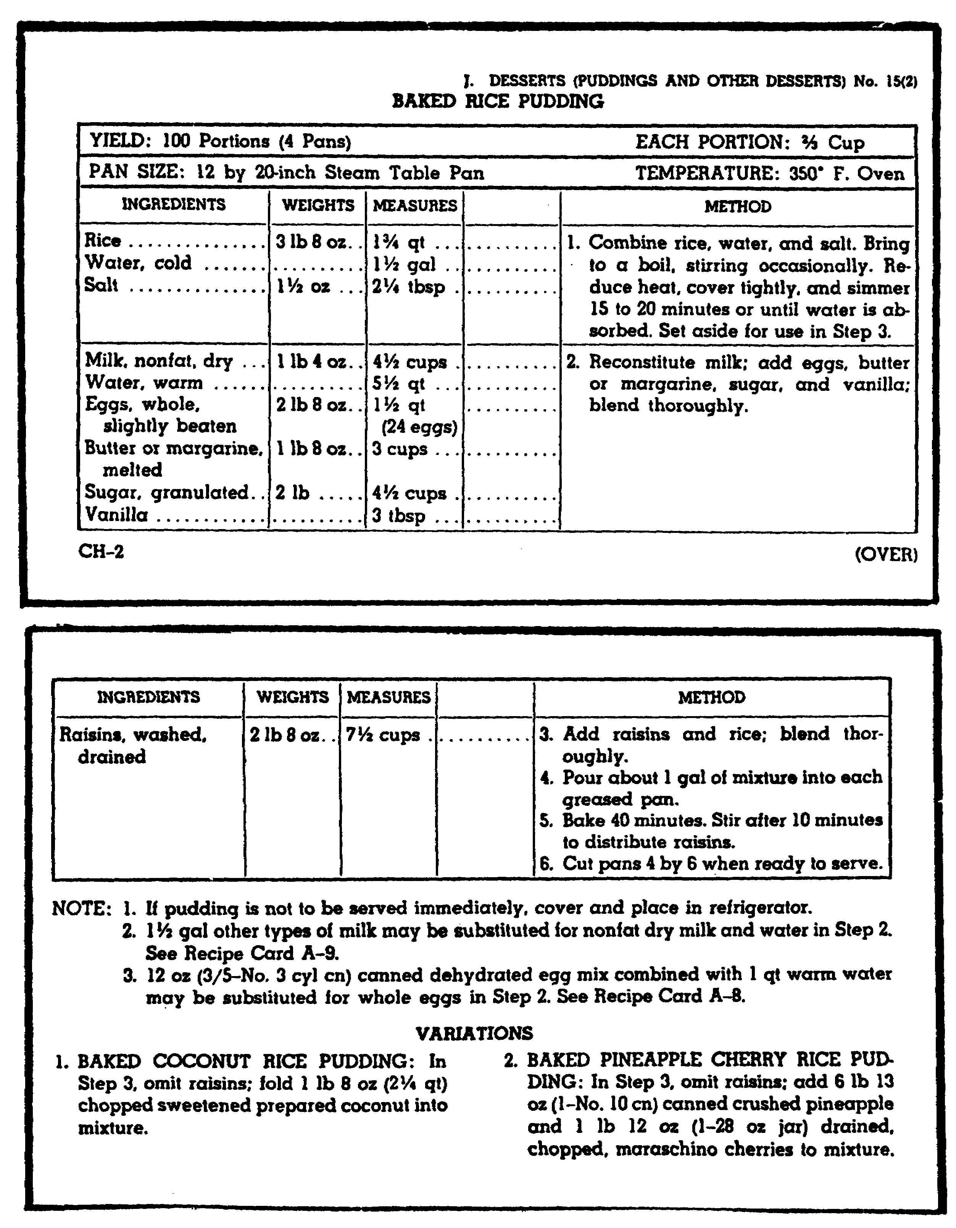

Figure 1. Recipe from the Armed Forces Recipe Service (TM 10-412) for
baked rice pudding.

44

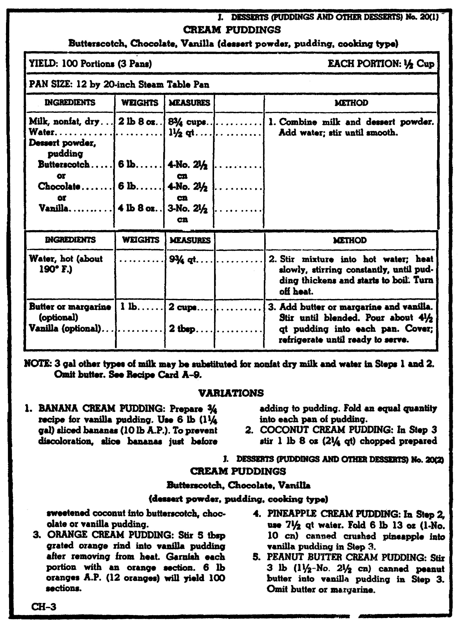

Figure 2. Recipe from the Armed Forces Recipe Service (TM 10-412) for
vanilla cream pudding.

45

a. Raw Fruits. Any fruit that can be eaten raw can be served raw for dessert. The fruit should be ripe and at the peak of its flavor, texture and color. Some raw, fresh fruits, such as apples, apricots, and pears, may be served with the skins left on. When this is done, the fruit should be washed well in cold water just before serving. Special care should be taken to wash those places where insect spray may have lodged, for example, around the stem or blossom end of the apple. Raw fresh fruits should be served at the temperature best suited to each particular type. Different fresh fruits are often mixed to make a fruit cup; for example, oranges, peaches, bananas, and strawberries.

(1) Strawberries. Fresh strawberries should be washed, drained well, and the stems removed just before serving. A small amount of sugar will draw out the juice and add to the flavor. They should be served slightly chilled.

(2) Grapes. Fresh grapes make a light, refreshing dessert to top off a heavy meal. They should be washed well, drained, and kept in the refrigerator until serving time. For dessert, they should be broken into small bunches and served cool.

(3) Melons. Melons received by the Armed Forces include cantaloupes, honeydews, casabas, honeyballs, and watermelons. Cantaloupes should be served at near room temperature for the best flavor and aroma. Honeydews, casabas, and honeyballs are usually served cold. Watermelons are usually chilled before serving. Melons may be served in slices, wedges, or cubes. Sometimes they are served with salt or a slice of lemon or lime, especially cantaloupes, honeydews, and casabas. Sometimes halves of small, cool cantaloupes are filled with a scoop of vanilla ice cream for single servings.

(4) Pineapples. Fresh pineapples are a tart dessert that adds a tang to a bland main dish, such as a seafood casserole, or a heavy dish, such as baked ham. The raw pineapple is peeled with a long, sharp knife, starting at the top and cutting down. The eyes are removed with a sharp knife. Cones of pineapples may be eaten from the hand, or wedges and chunks may be eaten with a fork or spoon. A small amount of sugar makes the fruit juicier and more enjoyable to most people. Fresh pineapple should be served cool, but not iced.

46

(5) Peaches, bananas, pears, and apples. These fruits may be served whole at a meal and eaten from the hand. They may be peeled, sliced right into the serving dish, and then served with a small amount of sugar, cream, or a fruit juice over them. Lemon, pineapple, or lime juice sprinkled over the cut fruit will keep it from discoloring. Peaches may be cooled or chilled. Pears and apples may be served cooled or at room temperature. Bananas should not be kept in the refrigerator because they are best at room temperature. Different types of fruit may be served whole at a meal so that each person can choose the fruit he or she likes best. Many people will want to take the whole fruit with them from the dining facility for a later snack, especially after a heavy meal.

(6) Citrus fruits. Citrus fruits, such as oranges, tangerines, and grapefruit, can be served as a dessert. Oranges and grapefruits are usually cut in half and eaten with a spoon, or they are peeled and cut into sections. Tangerines, because of their small size and shape, are usually peeled, and eaten from the hand. Sugar is often used on grapefruits and some kinds of oranges, and salt is sometimes sprinkled on grapefruit for a better flavor. Fresh oranges and grated or flaked coconut are the basic ingredients of ambrosia. Other fruits, such as bananas or cherries, may be added.

b. Cooked fresh fruits. Some kinds of fresh fruits, such as peaches, pears, plums, and apples, are good for dessert when cooked. They may be stewed, baked, broiled, or glazed.

(1) Stewed. Fruits for stewing are usually cut into slices and either cooked to get a mushy sauce or to keep the shape of the slices. They are usually stewed in water or syrup. When fruits are stewed in plain water, they tend to soak up the water and puff up and cook into an unwanted mush; but when fruits are stewed in syrup, they tend to hold their shape and to stay firm. A fruit sauce for desserts is made by cooking the fruit in water and then adding a small amount of sugar so that the true flavor is not hidden. If solid pieces with clean cut edges are wanted, the fruit should be dropped into a thin to medium sugar syrup. The fruit should be cooked in a covered pan over medium heat to keep the liquid and the fragrance from evaporating. Too much cooking will make the color of the fruit too dark and the fruit will also lose some of its flavor. As soon as the fruit is soft enough to be pierced easily with a toothpick, it is usually cooked the way that most people like it.

47

(2) Baked. Some kinds of fruits, such as apples, pears, and bananas, are good when baked. The fruit will not lose its shape if it is baked in a 375°F oven.

(3) Glazed. Glazing of fruit is best done in the oven. A syrup of sugar, water, and seasoning is fixed by following the recipe. The fruit is placed in a pan, covered with the syrup, and baked until tender. The fruit should be turned once while cooking.

(4) Broiled. Some kinds of fruits, such as peaches and pears, may be broiled. Ingredients, such as lemon juice, spice, and herbs, may be added for flavor, and the fruit is broiled until tender, not mushy.

c. Dried fruits. Dried fruits are those fruits from which water has been removed by natural or artificial means. Dried fruits, such as prunes, apricots, apples, and peaches, may be stewed with or without adding sugar, and flavored with lemon slices and a small amount of cinnamon. Dried fruits may be cooked separately, or some fruits, such as apricots, prunes, and peaches, may be cooked together. Some dried fruits need more water per pound while cooking than other fruits. For example, stewed dried apricots need 1 gallon of water for every 3 1/2 pounds of fruit, while stewed dried peaches need 2 gallons of water for the same amount of fruit. The recipe for stewing each kind of dried fruit should be followed. Cooked dried fruits, such as prunes or apricots, may be used in a whip, which is a dessert made of cooked dried fruit which has been pressed through a sieve, and stiffly beaten egg whites to which sugar, salt, and lemon juice have been added. Fruit whip is served cold.

d. Frozen fruits. Frozen fruits are thawed following the directions on the carton. They are used for dessert the same as diced or sliced fresh fruits.

e. Canned fruits. Almost all canned fruits, such as peaches, plums, pears, apricots, applesauce, berries, and mixed fruits can be served for dessert. They may be served separately or combined, plain or with a topping, hot or cold. They are an ideal dessert for a heavy meal.

48

5. GELATIN DESSERTS. Gelatin desserts made with flavored gelatin and water are light and simple desserts. They are especially good with a heavy meal or in hot weather. Cut-up fruits or whole small fruits, such as cherries and berries, may be added to flavored gelatins to make many different kinds of desserts. Gelatin desserts are fixed in the pans in which they are to be served. To keep the gelatin cold, only one pan of gelatin should be taken out of the refrigerator at a time, and it should be placed on the refrigerator counter. Gelatin desserts may be allowed to set until they become about as thick as a heavy syrup, then they are beaten until fluffy, chilled until firm, and served plain or with a topping, such as whipped cream. A recipe from TM 10-412 for fruit gelatin is given in figure 3.

49

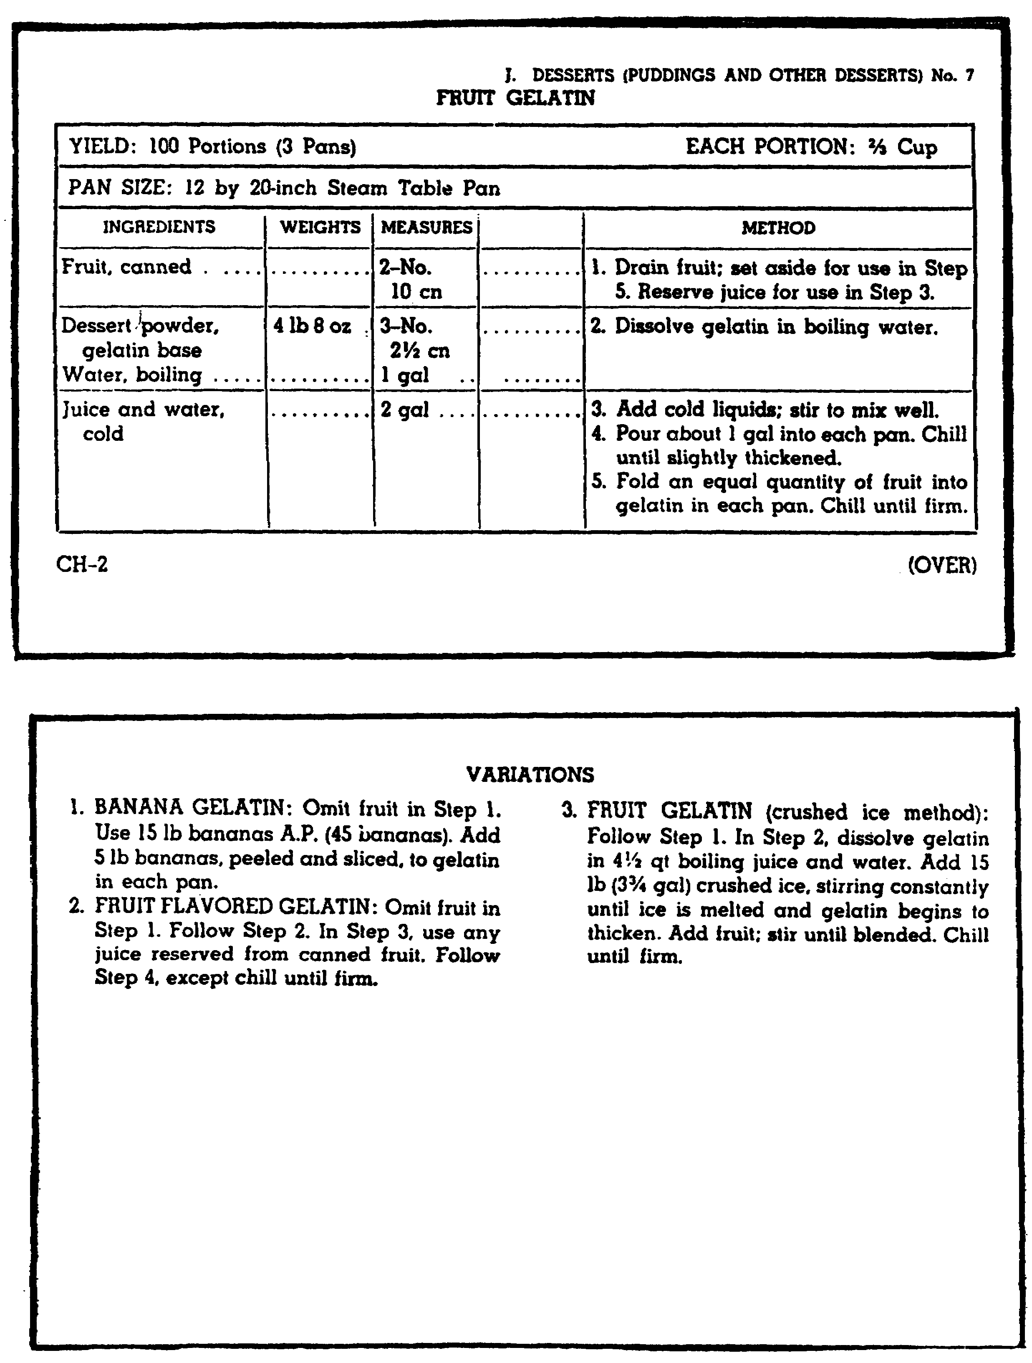

Figure 3. Recipe from the Army Forces Services (TM 10-412) for fruit
gelatin.

50

REVIEW EXERCISE

The questions in this review exercise give you a chance to see how well you have learned the material in lesson 4. The questions are based on the key points covered in the lesson.

Read each item and write your answer on the line or lines provided for it. Please use a pencil to write your answers. If you do not know, or are not sure what the answer is, check the paragraph reference that is shown in parentheses right after the item; then go back and study or read once again all of the referenced material and write your answer.

After you have answered all of the items, check your answers with the Solution Sheet at the end of the Review Exercise. If you did not give the right answer to an item, erase it and write the correct solution in the space instead. Then, as a final check, go back and restudy the lesson reference once more to make sure that your answer is the right one.

REQUIREMENT. Exercises A1 through A5 list various desserts. In the space provided, indicate whether they would be appropriate to serve with a heavy or light meal.

A1. Bread pudding with whipped topping. _______________ (para 2a)
A2. Baked pineapple cherry rice pudding. _______________ (para 2a)
A3. Fresh mixed fruit cup. _______________ (para 4)
A4. Canned mixed fruit. _______________ (para 4e)
A5. Strawberry gelatin. _______________ (para 5)

SITUATION. As a cook, you are required to prepare a cream pudding and a baked pudding. Listed below are methods used for preparing puddings.

REQUIREMENT. In the space provided following each method, indicate whether it is used for a baked pudding or a cream pudding.

51

A6. Reconstitute milk. Set aside for use in step 3. Mix eggs, sugar, salt, and vanilla; beat well. Add milk a little at a time; mix well. Pour 3 quarts of mixture into each ungreased pan. Sprinkle top of mixture lightly with nutmeg. ____________________ (para 3a)

A7. Mix rice, water, and salt. Bring to a boil stirring occasionally. Reduce heat, cover tightly, and simmer 15 to 20 minutes or until water is absorbed. Set aside for use in step 3. Reconstitute milk; add eggs, butter or margarine, sugar and vanilla; blend well. Add raisins and rice; blend well. Pour about 1 gallon of mixture into each greased pan. ____________________ (para 3a)

A8. Reconstitute milk.
Add sugar and salt; bring to just below boiling. DO NOT BOIL. Combine cornstarch, sugar, and water. Stir until smooth. Add to hot mixture and cook until thickened, stirring all the time. Stir about 1 quart mixture into eggs. Pour slowly into remaining hot mixture, stirring all the time. Continue heating until mixture returns to a boil. Stir frequently. Remove from heat. Add butter or margarine and vanilla. Mix to blend well.
Pour 1 gallon into each pan. ____________________ (para 3b)

REQUIREMENT. Exercises A9 through A10 are completion exercises. Fill in the blanks with the correct word.

A9. Several raw, fresh fruits, such as strawberries, oranges, and bananas, mixed in an individual serving make up a fruit _________.(para 4a)

A10. Some fresh fruits, such as peaches, pears, and apples, served for dessert may be cooked by broiling, glazing, _________________ or _________________. (para 4b(1) and (2))

DO YOU UNDERSTAND EVERYTHING IN THIS REVIEW EXERCISE? HAVE YOU CHECKED YOUR RESPONSES, MADE CORRECTIONS, AND RESTUDIED THE TEXT, IF NECESSARY? IF YOU HAVE, GO ON TO THE NEXT STUDY UNIT OF THIS SUBCOURSE.

52

EXERCISE SOLUTIONS

EXERCISE SOLUTION

A1. light

A2. light

A3. heavy

A4. heavy

A5. heavy

A6. baked

A7. baked

A8. cream

A9. cup

A10. stewing, baking

53

LESSON 4

OBJECTIVE TASK No. 101-524-1162. Prepare and Cook Egg Products.

TASK: When you successfully complete this assignment, you will be able to prepare and cook egg products. This includes the following performance measures:

1. Measure or weigh each ingredient using measuring spoons, scales, a quart dipper, or a measuring cup.

2. Process ingredients for use by following the procedures listed in the method column on the recipe card.

3. Combine ingredients by blending, mixing, folding, beating, stirring, and whipping.

4. Make up ingredients into serving portions according to procedures on the recipe card.

5. Place eggs in pan or on the griddle and follow cooking method on the recipe card.

a. Select equipment required by the cooking method.

b. Prepare equipment for use.

c. Arrange items in pans or on griddle.

6. Cook egg products for the periods of time shown on the recipe card.

55

CONDITIONS: You are a cook assigned to a garrison dining facility or a field kitchen. You must now prepare and cook egg products. This task is performed in a garrison dining facility or in a simulated combat situation under all environmental conditions.

CREDIT HOUR: 1

REFERENCES: TM 10-412, Armed Forces Recipe Cards
FM 10-25, Preparation and Serving of Food in the
Garrison Dining Facility

56

LESSON TEXT

1. INTRODUCTION. Eggs are one of the most nutritious and best liked of the basic foods. Shell eggs and dehydrated eggs are used in the dining facility. Eggs should be stored in a refrigerator away from foods with strong smells because smells can get into the eggs through the shells. Eggs should be taken out of the refrigerator 60 minutes before using them so that the eggs will cook evenly and so the shells will not crack when the eggs are cooked in the shells. Also, you will not have to beat the eggs for as long a time, and beaten egg whites will turn out bigger and better if the eggs are taken out of the refrigerator.

2. WAYS TO COOK EGGS. If you are going to cook two or more eggs together out of the shells, or if you will be mixing eggs with other ingredients, the eggs should be broken separately into a small dish; this way, if there is any egg that looks or smells bad, it can be thrown away without spoiling the good eggs or the other ingredients. Eggs served as a breakfast food may be soft cooked, hard cooked, scrambled, fried, baked or shirred, poached, or made into an omelet. Most dining facilities serve eggs to order. Two eggs are allowed per person.

a. Soft- and hard-cooked eggs. The Armed Forces Recipe Service gives a recipe for cooking 200 eggs. It is better, however, if no more than 50 eggs are soft- or hard-cooked at one time so that each person is served freshly cooked eggs and to make sure that all the eggs are cooked the right way. When you are either soft cooking or hard cooking eggs, place them in a pan of hot water and bring the water to a boil. Reduce the heat and simmer the eggs for 4 minutes if soft-cooking and 10-15 minutes if hard-cooked eggs are wanted. Hard-cooked eggs are taken off the heat and covered with cold water so that the eggs will not cook any more. The cold water also makes it easier to take the shells off the eggs, and it stops a green ring from forming around the yolk of the egg. Sometimes hard-cooked eggs crack while they are cooking because of rough handling or because the cook did not take the eggs out of the refrigerator and let them warm to room temperature before cooking.

b. Scrambled eggs. Usually, one tablespoon of milk is used with each egg to make the eggs smoother and more tender. The milk and eggs are blended together, not beaten, so that the cooked eggs will not have a spongy look and taste caused by air bubbles. The mixture of milk and eggs is poured onto a lightly greased, 325°F griddle and stirred now and then while cooking. The eggs should be taken off the griddle while they are still moist, and they should be served right away. The eggs should not stand for more than 10 minutes before serving.

57

c. Poached eggs. Eggs may be poached in water, consomme, tomato juice, or meat or vegetable stock. A little acid, vinegar or lemon juice, and salt added to the liquid helps to harden the whites of the eggs. The liquid is brought to a boil and then is reduced to a simmer at 185°F. The eggs are dropped into the liquid and then simmered 3 to 5 minutes or until the whites of the egg set and the yolks are covered with a white film. The eggs are then lifted with a skimmer or a slotted spoon to let the liquid drain off, and are served right away on toast or in small serving dishes.

d. Fried eggs. Eggs can be fried in some kinds of fat, such as shortening or meat drippings (Figure 1). Butter and margarine are not used very much for frying eggs because solid fats (butter and margarine) burn and give a strange flavor and look to the eggs. The tops of eggs can be cooked without turning the eggs by basting them with some of the hot fat from the griddle using a metal spatula. A lid or pie pan placed over the eggs while they are cooking will give a soft, white look to the tops of the yolks.

58

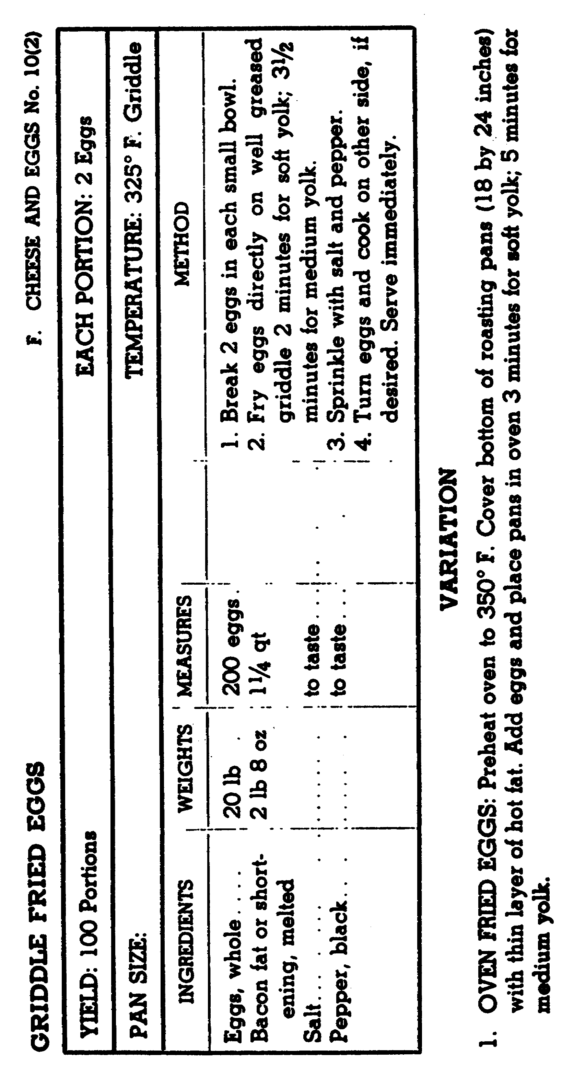

Figure 1. Recipe from the Armed Forces Recipe Service for fried eggs.

59

e. Omelets. The eggs are whipped with a wire whip just enough to blend yolks and whites, seasonings are added, and then one-third cup of the mixture is poured on a greased 325'F griddle. When the eggs are set, the omelet is folded in half. The omelet should be served right any or held no longer than 10 minutes in a hot steamtable pan. Before folding the omelet, bacon, cheese, or ham particles may be sprinkled on top of the egg mixture.

60

REVIEW EXERCISE

The questions in this review exercise give you a chance to see how well you have learned the material in lesson 4. The questions are based on the key points covered in the lesson.

Read each item and write your answer on the line or lines provided for it. Please use a pencil to write your answers. If you do not know, or are not sure what the answer is, check the paragraph reference that is shown in parentheses right after the item; then go back and study or read once again all of the referenced material and write your answer.

After you have answered all of the items, check your answers with the Solution Sheet at the end of the Review Exercise. If you did not give the right answer to an item, erase it and write the correct solution in the space instead. Then, as a final check, go back and restudy the lesson reference once more to make sure that your answer is the right one.

REQUIREMENT. Exercises A1 through A4 describe methods of cooking eggs to order. Complete the exercise by filling in the blank with the name of the method.

A1. Eggs that are cooked in the shell in boiling water for 15 minutes are __________________________. (para 13a)

A2. Eggs that are mixed with milk and cooked on a griddle, stirring occasionally, are __________________________. (para 13b)

A3. Eggs cooked without a shell in a boiling liquid are_________________. (para 13c)

A4. Eggs cooked on a griddle in a small amount of shortening, with or without turning, are __________________________. (para 13d)

61

REQUIREMENT. Exercises A5 through A10 deal with things you should know about handling, storing, and preparing eggs.

A5. Types of eggs used in the dining facility include _______________ and _______________ eggs. (para 1)

A6. Eggs are stored in the refrigerator away from foods with _______________ _______________(para 1)

A7. Eggs are taken out of the refrigerator _______________ minutes before using then. (para 1)

A8. Eggs should be broken _______________ into a small dish. (para 2)

A9. It is better to limit the number of eggs prepared at one time to _______________ so that each person can be served freshly cooked eggs prepared as desired. (para 2a)

A10. Eggs should be fried in _______________ or _______________ rather than butter or margarine. (para 2d and figure 1)

DO YOU UNDERSTAND EVERYTHING IN THIS REVIEW EXERCISE? HAVE YOU CHECKED YOUR RESPONSES, MADE CORRECTIONS, AND RESTUDIED THE TEXT, IF NECESSARY? IF YOU HAVE, GO ON TO THE NEXT STUDY UNIT OF THIS SUBCOURSE.

62

EXERCISE SOLUTIONS

EXERCISE SOLUTION

A1. hard cooked

A2. scrambled

A3. poached

A4. fried

A5. shell; dehydrated

A6. strong smells

A7. 30

A8. separately, or one by one

A9. 50

A10. fat; shortening

63

LESSON 5

OBJECTIVE TASK No. 101-524-1163. Prepare and Cook Cereal or Paste Products.

TASK: When you successfully complete this assignment, you will be able to prepare and cook cereal or paste products. This includes the following performance measures:

1. Measure or weigh each ingredient using measuring spoons, scales, a quart dipper, or a measuring cup.

2. Process ingredients for use by following the procedures listed in the method column on the recipe card.

3. Combine ingredients by blending, mixing, or stirring.

4. Place cereal or paste products in a pan.

5. Start cooking by applying heat according to procedures on the recipe card.

6. Test items for doneness.

7. Cook cereals and paste products for periods of time shown on the recipe card or until test shows they are done.

65

CONDITIONS: You must prepare and cook cereal or paste products. This task is performed in a garrison dining facility or in a simulated combat situation under all environmental conditions.

CREDIT HOURS: 1

REFERENCES: TM 10-412, Armed Forces Recipe Cards FM 10-25, Preparation and Serving of Food in the Garrison Dining Facility

66

LESSON TEXT

1. BREAKFAST MENUS. The breakfast served in military dining facilities is important because of the nutrition it gives and the way it keeps up morale. The breakfast will usually have fruit or juice; hot or cold cereal; ham, bacon, sausage, or creamed beef; eggs; french toast, toast, or griddle cakes; jam or jelly; and tea, coffee, or milk. Sweet rolls, coffee cake, or doughnuts are also on the master menu sometimes.

2. FRUITS AND JUICES. Fresh fruits are often on the master menu. Different kinds of fruit need different kinds of preparation. There are many different kinds of fruit served on the master menu, such as apples, bananas, cantaloupes, grapes, grapefruits, oranges, peaches, pears, plums, and tangerines. Canned fruits may be served sometimes. Many different kinds of juices - canned, fresh, frozen, or dehydrated – are served.

3. CEREALS. Cereals give a lot of energy and are good roughage for the body. In the past all breakfast cereals needed to be cooked for a long time, but now much of that work is done at the factory. Most cereals are made from wheat, rye, corn, oats, or buckwheat. Ready-to-eat dry cereals are served often in the dining facility.

a. Assorted dry ready-to-eat cereals. Dry cereals are packed in boxes just big enough for one serving, and each person can take the kind he or she likes best when going through the serving line.

b. Hot cooked cereals. There are many kinds of hot cooked cereals such as fine granules (farina or wheat meal), flaked grains (rolled oats and flaked wheat), and whole grains (rice and hominy). There are many different ways to mix the cereal with water because of the difference in size and shape of the grains. When cooking hot cereal, you must be very careful, especially with the smallest grains, to keep the cereal from getting lumpy. If the cereal gets too thick, thin it with a little boiling water. Cooked cereals can be reheated in a double boiler; they should not be stirred until well heated. Hot cooked cereals may be served with milk and sugar.

(1) Fine granular cereals. Fine granular cereals should be mixed with enough cold water so that a smooth paste will be made and there will be no lumping. The rest of the liquid is brought to a boil, and then the paste is slowly stirred in. This mixture is simmered for a prescribed amount of time, then taken off the heat and covered.

67

(2) Flaked grain cereals. Flaked grain cereals should be sprinkled gently into boiling salted water. A little stirring will keep the cereal from lumping. This cereal should be brought to a boil again, then simmered for about two (2) minutes over direct heat, while you stir it occasionally. It is then taken off the heat and covered for 10 minutes before serving. Too much stirring or too much boiling will make the cereal sticky and gummy. Different amounts of water are needed for each kind of flaked grain cereal, so read the recipe carefully.

(3) Whole grain cereals. Add whole grain cereal little by little to boiling water that has a little salt in it, then simmer the cereal until it is tender. The most important thing to remember when cooking whole grain cereals is to cook the grains until tender and to have them swell as big as they can without breaking. There should be no water in the bottom of the pan by the time the cereal is ready to be served.

4. PASTE. Macaroni, noodles, and spaghetti are all called paste products because they are made from flour and water. These paste products and rice are sometimes served to military personnel instead of potatoes or as a main dish when mixed with meat, cheese, or eggs. Rice is also put in this section because it is prepared and used like paste products.

5. MACARONI, SPAGHETTI, AND NOODLES. Macaroni, spaghetti, and noodles should be cooked in six to eight parts of water to one part of the paste product. Figure 1 gives the recipe for boiled pasta from TM 10-412. Other general rules for cooking and serving paste products include the following:

a. Cooking. Little by little, drop the macaroni, spaghetti, or noodles into rapidly boiling salted water or stock, stirring all the time so that boiling does not stop. The action of the boiling water moves the pieces and keeps them from sticking together. A small amount of salad oil added to the cooking water keeps the pieces from sticking to each other or to the container.

b. Timing. Keep on stirring the macaroni, spaghetti, or noodles until the water boils for the second time. Cooking time is measured from this point. Do not overcook paste products; cook about 15 minutes or until tender. Test paste products for doneness by tasting them or by pressing a piece of the product against the side of the container with a fork. If the piece breaks evenly and cleanly, the product is done.

68

c. Serving. Cook paste products until tender, drain well, and use at once. The cooked pasta will not have to be rinsed if it is to be mixed with butter or in a sauce. Cheese should be grated or chopped as fine as possible when it is to be added to a sauce because it must melt quickly or it will become tough and rubbery.

6. RICE. Rice is a grain product which grows in warm climates, chiefly in the Orient and in southern areas of the United States. Most rice used by the Armed Forces is milled, or polished, which means that the outside, or bran, has been removed. If bulk rice is received, it should be checked before it is cooked so that any foreign material packaged with the rice can be removed. Carefully follow the cooking directions of the company which packaged the rice. Some types of rice may need to be rinsed before they are cooked. The recipe from TM 10-412 for steamed rice is given in figure 2. Steamed rice is used for rice custards, puddings, and other rice desserts. It may be used instead of potatoes and served with butter, gravy, or a sauce for lunch or dinner.

69

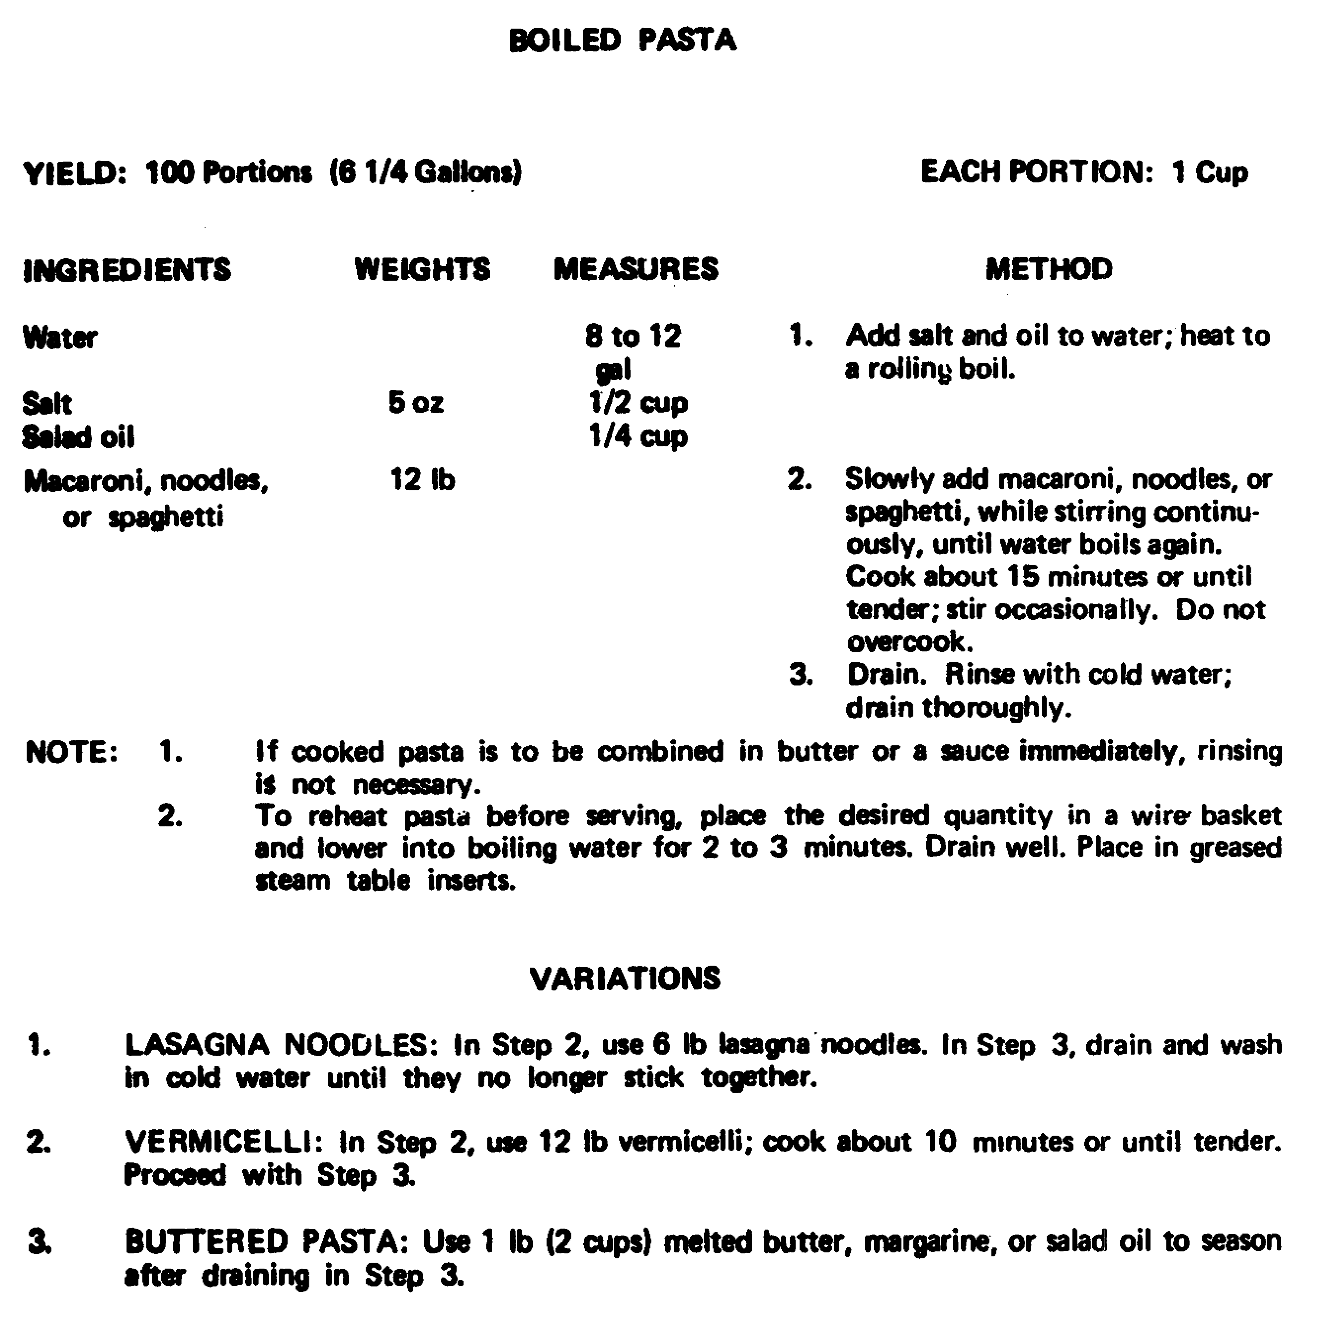

Figure 1. Recipe for boiled pasta from the Armed Forces Recipe Service.

70

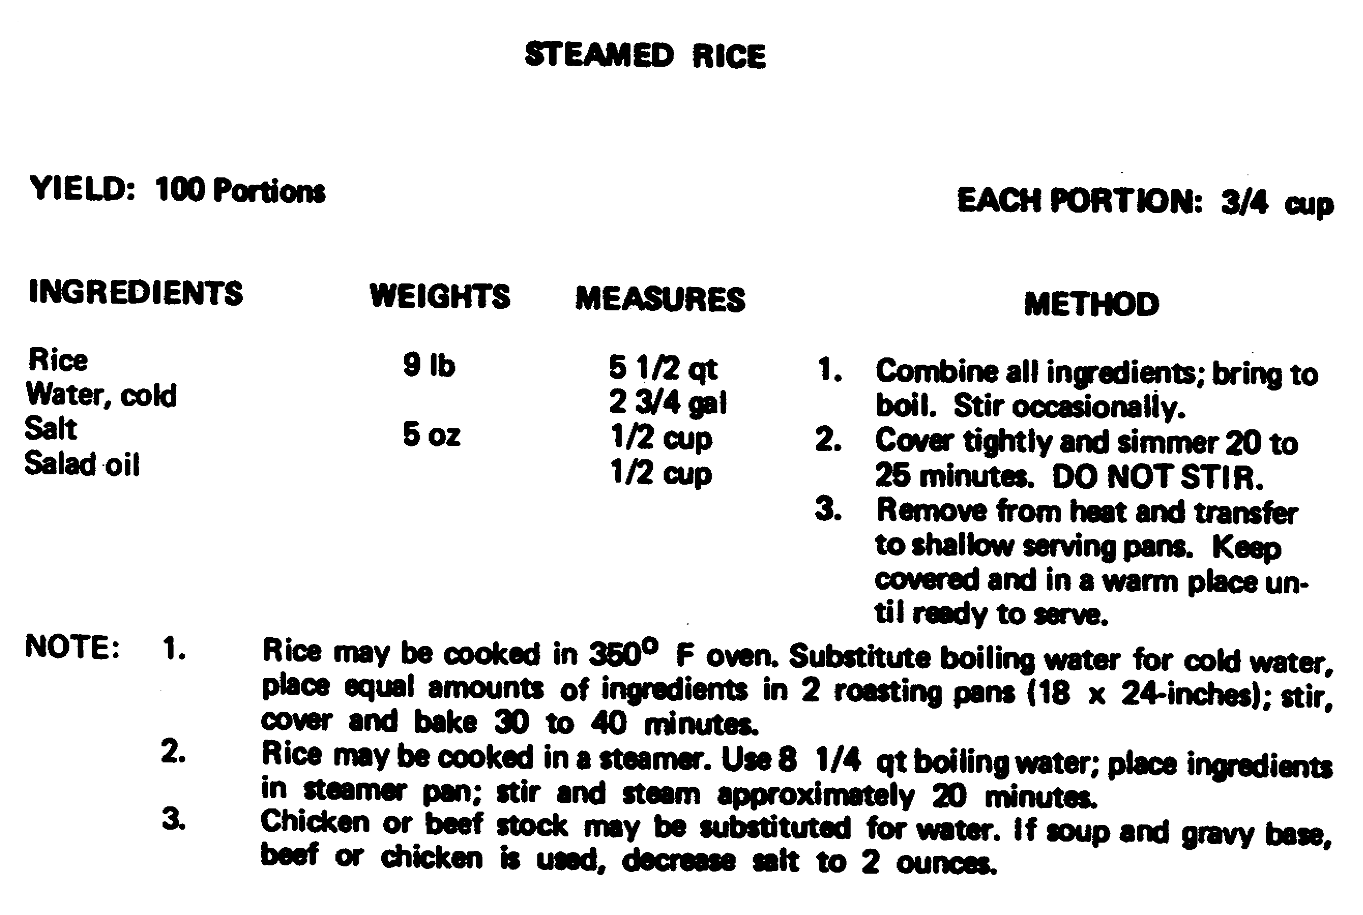

Figure 2. Recipe for steamed rice from the Armed Forces Recipe Service.

71

REVIEW EXERCISE

The questions in this review exercise will give you a chance to see how well you have learned the material in Lesson 5. The questions are based on the key points covered in the lesson.

Read each item and write your answer on the line or lines provided for it. Please use a pencil to write your answers. If you do not know, or are not sure, 'what the answer is, check the paragraph reference that is shown in parenthesis right after the item; then go back, and study or read once again all referenced material and write your answer.

After you have answered all of the items, check your answers with the solution sheet at the end of this exercise. If you did not give the right answer to an item, erase it, and write the correct solution in the space instead. Then, as a final check, go back and restudy the lesson reference once more to make sure that your answer is the right one.

REQUIREMENT. Exercises Al through A5 describe cooking conditions that are responsible for a desirable cooked cereal and paste product.

Put A in front of statements that describe conditions resulting in a smooth texture.

Put B in front of statements that describe conditions resulting in a product not sticking together.

Put C in front of statements that describe conditions resulting in doneness.

A1. _______ When cereal is cooked too thick, thin it with a little boiling water. (para 3b)

A2. _______ Finely granulated cereal should be mixed in cold water. (para 3b(1))

A3. _______ Little by little, macaroni, spaghetti, or noodles should be dropped into rapidly boiling water. (para 5a)

A4. _______ A small amount of salad oil is added to the cooking water. (para 5a)

A5. _______ Cooking time is important. (para 5b)

72

A6. REQUIREMENT. The method of cooking has been omitted from the following recipe extracted from TM 10-412. Complete the cooking instructions for the following recipe by filling in the blanks following the recipe. (para 6)

HOT BREAKFAST CEREALS

(Quick-Cooking Type)

YIELD: 100 Portions EACH PORTION: 3/4 Cup

CEREAL WEIGHT MEASURES SALT WATER

Farina 6 lb. 4 qt. 6 tbsp. 4 gal hot.
1 gal cold

Hominy grits 6 lb. 1 gal 6 tbsp. 4 1/2 gal.

Rolled oats 6 lb. 2 1/4 gal. 6 tbsp. 5 gal.

Whole wheat meal 6 lb. 4 1/2 qt. 6 tbsp. 4 1/2 gal..

Add salt and cereal to boiling water; stir to prevent ________________.
Return to a boil, reduce the heat and let ________________.
Turn off heat, ________________ and let stand.

DO YOU UNDERSTAND EVERYTHING IN THIS REVIEW EXERCISE? HAVE YOU CHECKED YOUR RESPONSES, MADE CORRECTIONS, AND RESTUDIED THE TEXT, IF NECESSARY? IF YOU HAVE, GO ON TO THE NEXT STUDY UNIT OF THIS SUBCOURSE.

73

EXERCISE SOLUTIONS

EXERCISE SOLUTION

A1. A

A2. A

A3. B

A4. B

A5. C

A6. lumping, simmer, cover

74

LESSON 6

OBJECTIVE TASK No. 101-524-1164. Prepare Beverages.

TASK: You must prepare beverage products according to the recipe card or food service SOP without error.

1. Measure or weigh each ingredient using measuring spoons, scales, a quart dipper, or a measuring cup.

2. Process ingredients for use by following the procedures listed in the method column on the recipe card.

3. Combine ingredients by blending, mixing, or stirring.

4. Make up ingredients into serving portions, when needed.

5. Apply heat or chill when needed, according to the recipe card.

6. Brew, steep, or chill beverages for the periods of time shown on the recipe card.

CONDITIONS: You will be given a situation regarding preparation of beverage products in a garrison dining facility or a field kitchen.

CREDIT HOUR: 1

REFERENCES: TM 10-412, Armed Forces Recipe Cards
FM 10-25, Preparation and Serving of Food in the Garrison Dining Facility

75

LESSON TEXT

1. GENERAL. Beverages are important at meal time and during the day. They provide liquids which the body needs to stay healthy and, when fixed and served in the right way, make the meal more pleasant. Coffee and tea do not help the body's nutrition, but they do have ingredients (stimulants) which help us feel less tired for a while. The warmth of a hot drink can also work as a stimulant. Hot cocoa is good for nutrition and has a stimulating effect. Fruit drinks, milk drinks, and egg nog are beverages which are good for nutrition and are very refreshing when chilled in the right way. In the Armed Forces, serving different beverages over a long period of time is important for morale.

2. COFFEE. The ingredient in coffee which gives it its special coffee flavor and smell is called caffeol. The bitter ingredient in coffee is called tannin. Tannins are dissolved in water at 185°F and above. Coffee gets a bitter, unpleasant taste when it is heated above this temperature, when it stands too long in the pot, when the coffee is reheated, or when you use unclean equipment or equipment made of iron to make the coffee. The ground coffee should be stored in clean, airtight containers until it is used, and the supply of coffee which came to the kitchen earliest should be used before the coffee which cane later so that the flavor, strength, and smell will not be weakened. Coffee grounds should not be reused because coffee made from reused grounds is weak and bitter.

3. METHODS OF PREPARING COFFEE. There are three important things to remember when making good coffee: use clean equipment, use fresh cold water, and use the right amounts of coffee and water. Equipment that has not been cleaned the right way may have coffee oil on the inside and coffee oil gives the coffee a stale and bitter taste. Always use the amounts of coffee and water which the Armed Forces Recipe Service (TM 10-412) says to use so that the coffee will not be too weak or too strong. Coffee should not be fixed more than 15 minutes before serving, it should not be held for more than an hour, and it should be kept at the right temperature so that the coffee will not get a bitter taste. Coffee may be served hot or iced.

a. Hot coffee. Hot coffee may be fixed from ground coffee or instant coffee. Because there are many different kinds of coffee makers and coffee urns, always follow the directions of the company which made the equipment and the recipes in TM 10-412.

76

b. Iced coffee. The ways to fix iced coffee are the same as for hot coffee, but when making iced coffee only use one-half as much water as you use when making hot coffee. The coffee is poured over crushed ice or ice cubes in glasses. For special meals, a tablespoon of whipped cream or ice cream can be used to garnish a glass of iced coffee. There should be ice and coffee in the dining area so that each person who wants iced coffee can fix his or her own serving. Do not fix iced coffee ahead of serving time because then the coffee will be diluted by the melting ice.

4. TEA. Tea like coffee, does nothing to help the body's nutrition unless it is mixed with sugar, cream, or milk. Tea also has a stimulant called theine. Tea leaves should be kept in airtight, nonwood containers to protect them from air and moisture. Tea leaves should also be protected from sunlight, too much heat, and rough handling. Packages .of tea which are already opened should always be used before opening new packages.

a. Hot tea. Fresh tea, freshly boiled water, and the right amounts of tea and water should be used. An iron container should never be used to boil or steep tea because the iron will make the tea dark and bitter. The actual steeping (putting the tea into boiling water which has just been taken off the heat, and keeping it in the hot water for a while) should not take more than 5 minutes. If loose tea leaves are used, filter them out of the tea right after steeping. If the tea is cloudy, clear it by adding a little boiling water. The hot tea should
be held between 175°F and 1850F.

b. Iced tea. When making iced tea, only use one-fourth as much water as you use for making hot tea. Always cool the tea before serving it over ice. Iced tea may be garnished with wedges or slices of lemon, lime, or orange, or a sprig of mint. Tea can also be used as an ingredient in many fruit punches.

5. COCOA. Because it has fat in it, cocoa should be stored in a clean, dark place so that it will not get stale or absorb strange odors. Hot cocoa is a stimulating and nutritious beverage.

a. Hot cocoa. The dry ingredients should be mixed and then the water can be added to make a thin, smooth paste. The mixture is simmered just below the boiling point from 185°F to 210°F. Scalded (heated almost to boiling) milk is then added and heated to just below boiling so that it won't scorch.

77

b. Iced cocoa. Iced cocoa is made by chilling and whipping hot cocoa. Vanilla favoring may be added or the iced cocoa can be topped with whipped cream or ice cream.

6. CHILLED FRUIT DRINKS. Chilled fruit drinks are refreshing and nutritious because they have vitamin C and sugar. There are many different kinds of chilled fruit drinks which are served to military personnel, such as lemonade, grapeade, limeade, fruit punch, and other fruit drinks made with fruit punch. Frozen, canned, or fresh fruit juice may be used. Fruit punches are usually made from two or more different fruit juices. Tea is sometimes used as an ingredient for fruit punches. When sugar must be added to chilled juice, it is added to the juice in a sugar syrup. Plain sugar syrup is made by dissolving six parts of sugar in four parts of water and cooking the mixture for 5 minutes. The syrup should be cooled and then used as needed. Fruit drinks may be garnished with different kinds of fruits, such as cherries, banana slices, pineapple tidbits, raspberries, slices of citrus fruits, or mint sprigs. Glasses can be given a frosty appearance by chilling and dipping the edges in powdered sugar. A beverage base powder which comes in several flavors can also be used.

7. MILK DRINKS. Milk drinks are refreshing and nutritious; they can be made from nonfat dry milk, whole dry milk, evaporated milk, or whole fresh-milk. Eggnog is very nutritious and should be served in the holiday season. You can get eggnog in a ready-to-serve type which is kept in the refrigerator or in a canned type which is also ready-to-serve, but does not need to be refrigerated. Eggnog may also be fixed in the dining facility, but you must always use fresh eggs. Plain eggnog is made by beating whole eggs with salt and sugar until thick and lemon colored, and then blending the mixture with the other ingredients. Foamy eggnog is made by beating the egg yolks with the sugar until the mixture is thick and lemon colored. The stiffly beaten egg whites and salt are folded into the egg yolk-sugar mixture. Both plain and foamy eggnog should be refrigerated for 30 minutes before serving. Leftover eggnog should be thrown away.

78

REVIEW EXERCISE

The questions in this review exercise will give you a chance to see how well you have learned the material in Lesson 6. The questions are based on the key points covered in the lesson.

Read each item and write your answer on the line or lines provided. Please use a pencil to write your answers. If you do not know, or are not sure, check the paragraph reference that is shown; then go back, read all referenced material and write your answer.

After you have answered all of the items, check your answers with the solution sheet at the end of this exercise. If you did not respond correctly, erase and write the correct solution in the provided space.

REQUIREMENT. Exercises Al through A6 describe conditions that are responsible for unacceptable coffee.

Put A in front of statements that describe conditions resulting in a bitter flavor.

Put B in front of statements that describe conditions resulting in weak coffee flavor and aroma.

Put C in front of statements that describe conditions resulting in both bitter and weak flavor.

A1. _______ The coffee grounds were not stored in an airtight container. (para 2)

A2. _______ The coffee is reheated using the same grounds. (para 2)

A3. _______ The coffee was made 2 hours before serving time. (para 3)

A4. _______ Too much water was used in proportion to the amount of coffee. (para 3)

A5. _______ The equipment was not cleaned the right way after the last use.
(para 3)

A6. _______ Iced coffee is made using the same amount of coffee and water as is used to make hot coffee. (para 3b)

A7. Cloudy tea may be cleared by adding a small amount of _____________________. (para 4a)

A8. Cocoa may be scorched when it is ______________. (para 5a)

A9. Water can be added to _______ ingredients to make a smooth paste. (para 5a)

79

EXERCISE SOLUTIONS

EXERCISE SOLUTION

A1. B

A2. C

A3. A

A4. B

A5. A

A6. B

A7. boiling water

A8. boiled

A9. dry

80

